‘Thy kingdom come!’ on bended knee Hymnal 1982 no. 615 Melody: St. Flavian C.M.
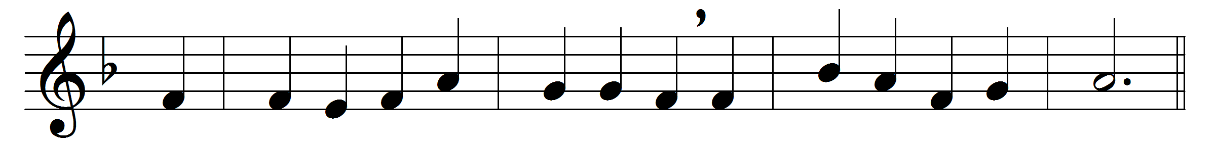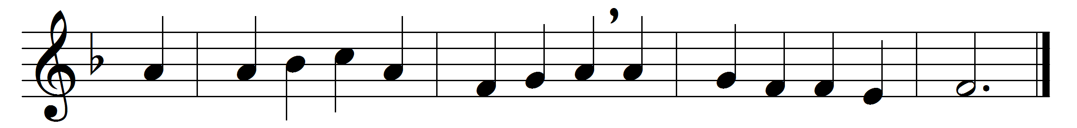

‘Thy kingdom come!’ on bended knee
the passing ages pray;
and faithful souls have yearned to see
on earth that kingdom’s day.

But the slow watches of the night
not less to God belong;
and for the everlasting right
the silent stars are strong.

And lo, already on the hills
the flags of dawn appear;
gird up your loins, ye prophet souls,
proclaim the day is near:

the day to whose clear shining light
all wrong shall stand revealed,
when justice shall be throned in might,
and every hurt be healed;

when knowledge, hand in hand with peace,
shall walk the earth abroad;
the day of perfect righteousness,
the promised day of God.

Words: Frederick Lucian Hosmer (1840-1929)
Music: Adapted from Psalms, 1562

