Judge eternal, throned in splendour Hymnal 1982 no. 596
Melody: Komm, o komm, du Geist des Lebens 8 7. 8 7. 8 7.
British spelling
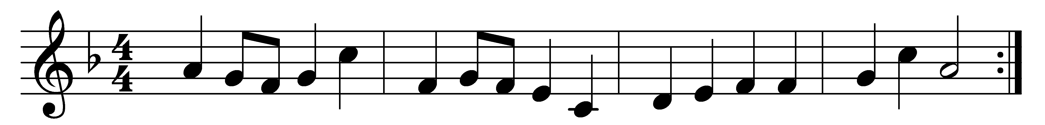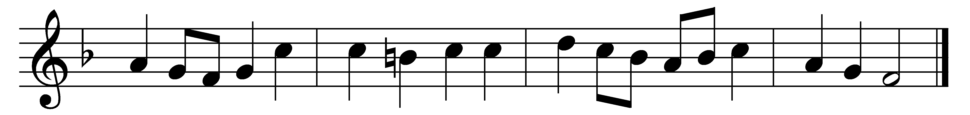

Judge eternal, throned in splendour,
Lord of lords and King of kings,
with thy living fire of judgement
purge this land of bitter things;
solace all its wide dominion
with the healing of thy wings.

Still the weary folk are pining
for the hour that brings release,
and the city’s crowded clangour
cries aloud for sin to cease;
and the homesteads and the woodlands
plead in silence for their peace.

Crown, O God, thine own endeavour;
cleave our darkness with thy sword;
feed all those who do not know thee
with the richness of thy word;
cleanse the body of this nation
through the glory of the Lord.

Words: Henry Scott Holland (1847-1918)
Music: Melody from Neu-vermehrtes und zu Übung Christl. Gottseligkeit eingerichtetes Meiningisches Gesangbuch, 1693

