Teach me, my God and King Hymnal 1982 no. 592 Melody: Carlisle S.M.
Words from AMNS
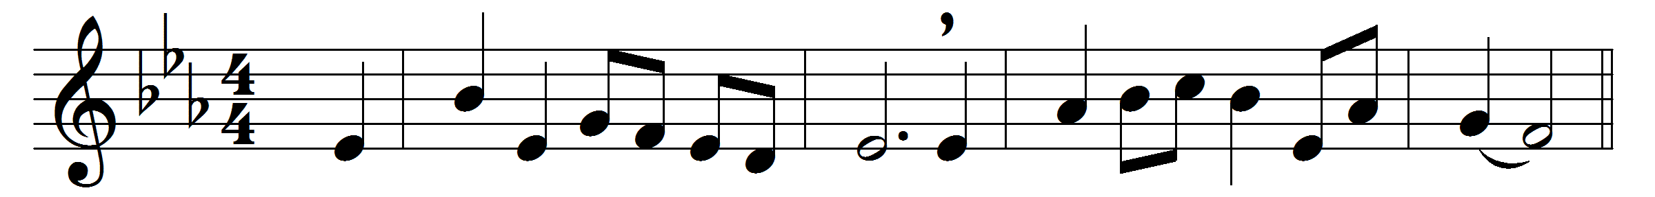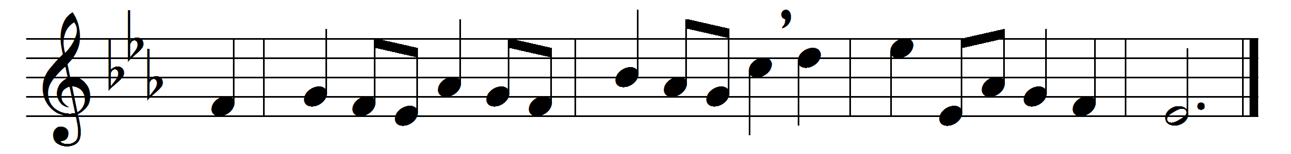

Teach me, my God and King,
in all things thee to see;
and what I do in anything
to do it as for thee.

A man that looks on glass,
on it may stay his eye;
or, if he pleaseth, through it pass,
and then the heaven espy.

All may of thee partake;
nothing can be so mean
which, with this tincture, For thy sake,
will not grow bright and clean.

A servant with this clause
makes drudgery divine;
who sweeps a room, as for thy laws,
makes that and the action fine.

This is the famous stone
that turneth all to gold;
for that which God doth touch and own
cannot for less be told.

Words: George Herbert (1593-1633)
Music: Charles Lockhart (1745-1815)

