O God of earth and altar Hymnal 1982 no. 591 Melody: Llangloffan 7 6. 7 6. D.
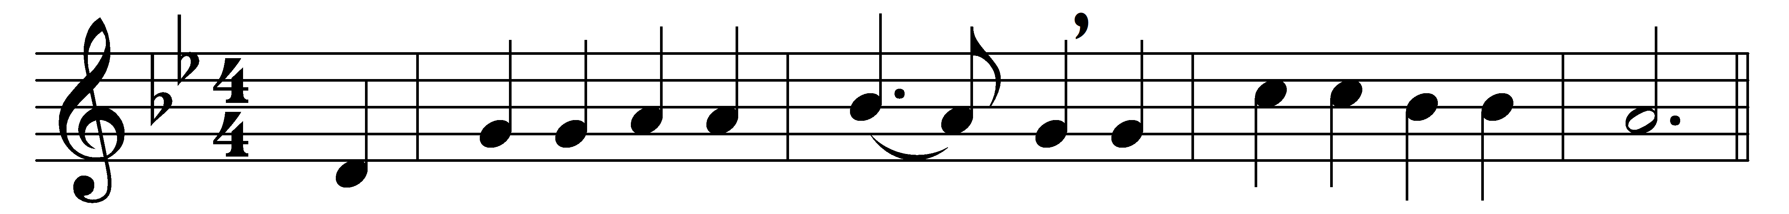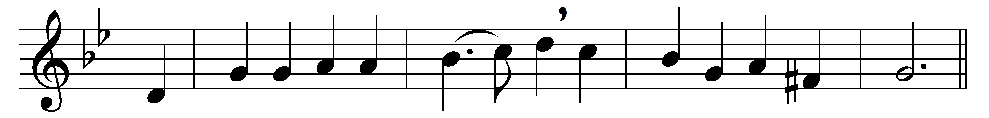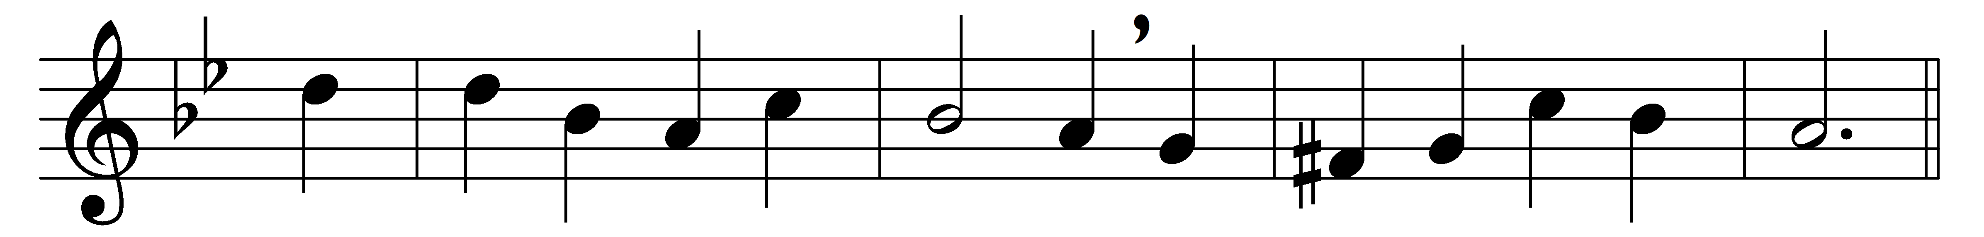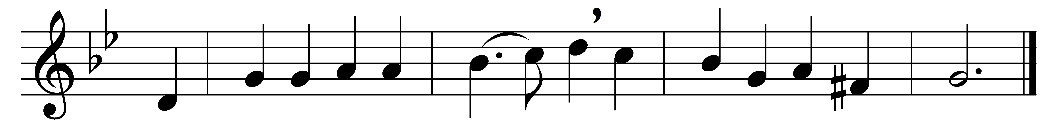

O God of earth and altar,
bow down and hear our cry,
our earthly rulers falter,
our people drift and die;
the walls of gold entomb us,
the swords of scorn divide,
take not thy thunder from us,
but take away our pride.

From all that terror teaches,
from lies of tongue and pen,
from all the easy speeches
that comfort cruèl men,
from sale and profanation
of honor, and the sword,
from sleep and from damnation,
deliver us, good Lord!

Tie in a living tether
the prince and priest and thrall,
bind all our lives together,
smite us and save us all;
in ire and exultation
aflame with faith, and free,
lift up a living nation,
a single sword to thee.

Words: Gilbert Keith Chesterton (1874-1936)
Music: Melody from Hymnau a Thonau er Gwasanaeth yr Eglwys yng Nghymru (1865)

