Before thy throne, O God, we kneel Hymnal 1982 no. 574 Melody: St Petersburg 8 8. 8 8. 8 8.
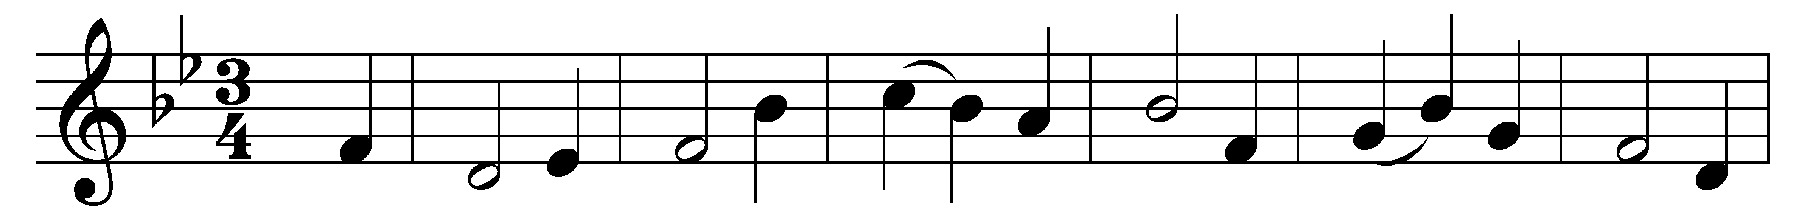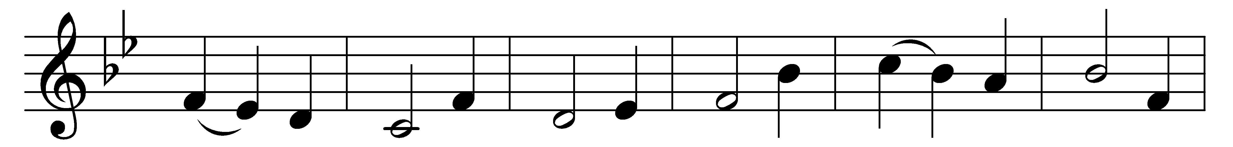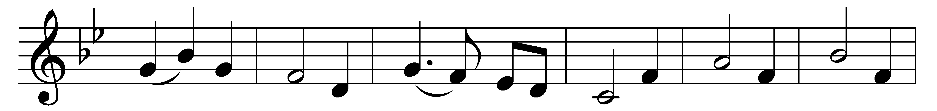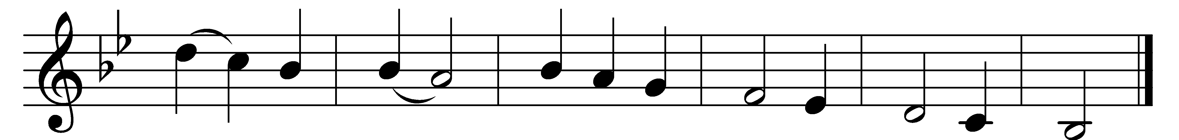

Before thy throne, O God, we kneel:
give us a conscience quick to feel,
a ready mind to understand
the meaning of thy chastening hand;
whate’er the pain and shame may be,
bring us, O Father, nearer thee.

Search out our hearts and make us true;
help us to give to all their due.
From love of pleasure, lust of gold,
from sins which make the heart grow cold,
wean us and train us with thy rod;
teach us to know our faults, O God.

For sins of heedless word and deed,
for pride ambitious to succeed,
for crafty trade and subtle snare
to catch the simple unaware,
for lives bereft of purpose high,
forgive, forgive, O Lord, we cry.

Let the fierce fires which burn and try,
our inmost spirits purify:
consume the ill; purge out the shame;
O God, be with us in the flame;
a newborn people may we rise,
more pure, more true, more nobly wise.

Words: William Boyd Carpenter (1841-1918)
Music: Dimitri S. Bortniansky (1751-1825)

