From thee all skill and science flow Hymnal 1982 no. 566
Melody: The Church’s Desolation D.C.M.
Words from AMNS
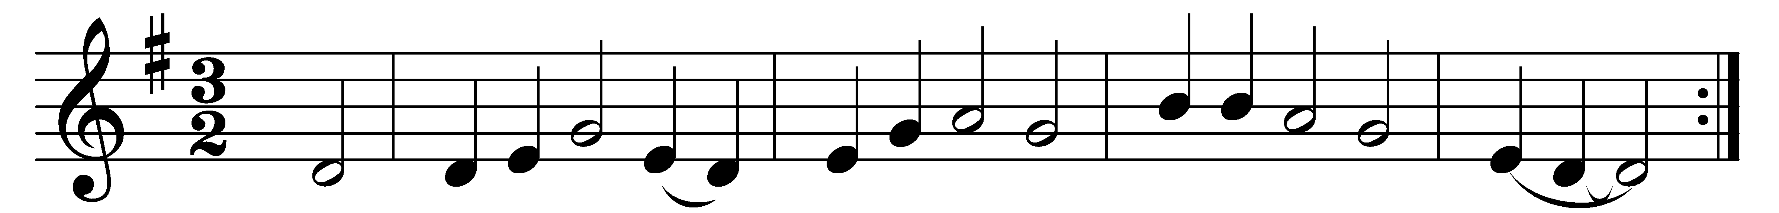

From thee all skill and science flow,
all pity, care, and love,
all calm and courage, faith and hope:
O pour them from above.
And part them, Lord, to each and all,
as each and all shall need,
to rise, like incense, each to thee,
in noble thought and deed.

And hasten, Lord, that perfect day
when pain and death shall cease,
and thy just rule shall fill the earth
with health and light and peace.
When ever blue the sky shall gleam,
and ever green the sod,
and man’s rude work deface no more
the paradise of God.

Words: Charles Kingsley (1819-1875)
Music: Traditional melody, harmonised by Jesse Tom White (19th century) and adapted by Claudius Hopkins Cayce (19th-20th century)

