He who would valiant be Hymnal 1982 no. 564 Melody: St Dunstan’s 6 5. 6 5. 6 6. 6 5.
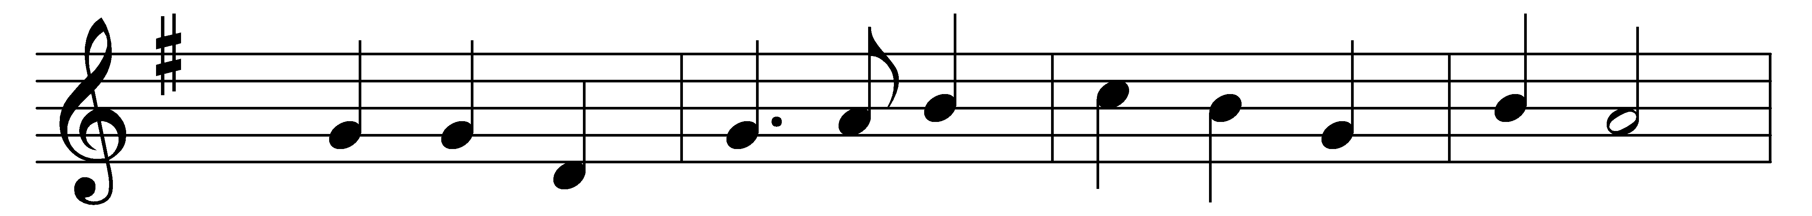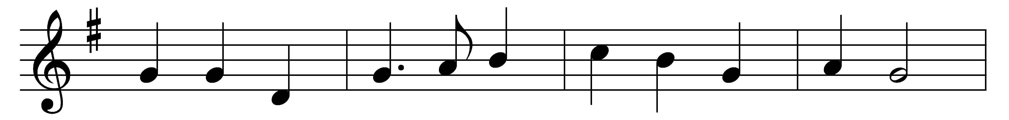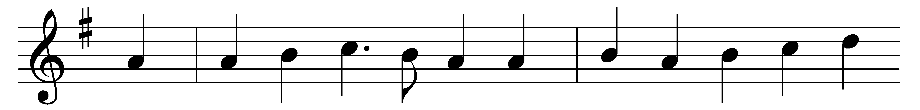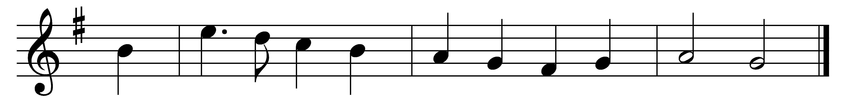

He who would valiant be
’gainst all disaster,
let him in constancy
follow the Master.
There’s no discouragement
shall make him once relent
his first avowed intent
to be a pilgrim.

Who so beset him round
with dismal stories,
do but themselves confound,
his strength the more is.
No foes shall stay his might,
though he with giants fight;
he will make good his right
to be a pilgrim.

Since, Lord, thou dost defend
us with thy Spirit,
we know we at the end
shall life inherit.
Then fancies flee away;
I’ll fear not what men say,
I’ll labor night and day
to be a pilgrim.

Words: Percy Dearmer (1867-1936), after John Bunyan (1628-1688)
Music: Charles Winfred Douglas (1867-1944)

