Faith of our fathers! Hymnal 1982 no. 558 Melody: St Catherine 8 8. 8 8. 8 8.
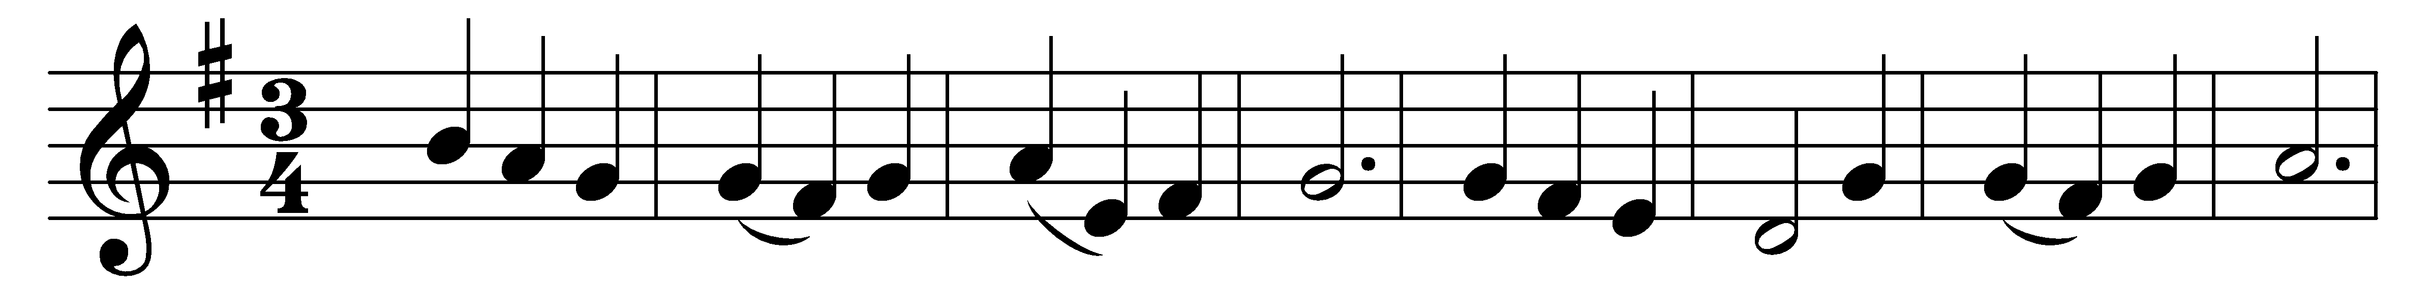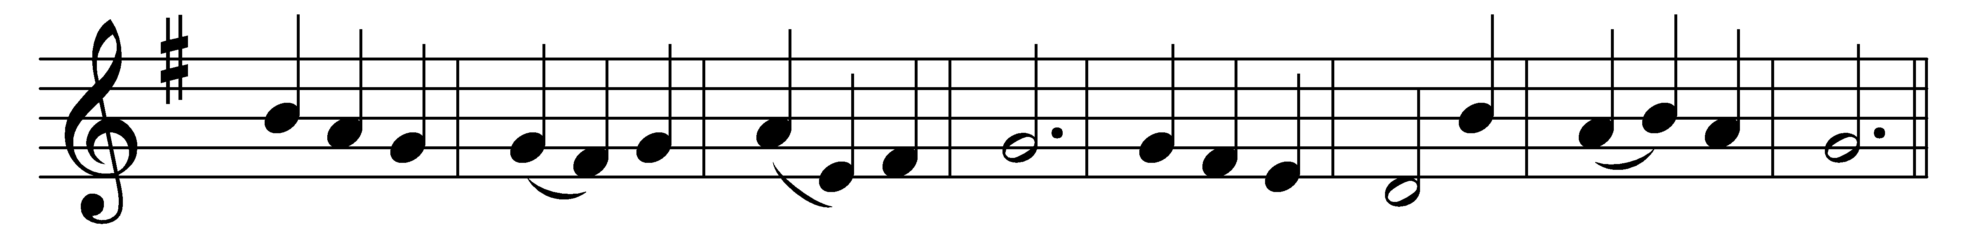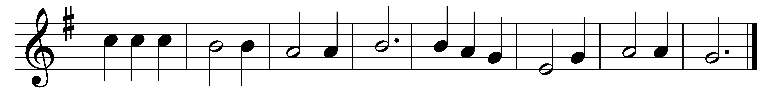

Faith of our fathers! living still
in spite of dungeon, fire, and sword:
O how our hearts beat high with joy,
when-e’er we hear that glorious word:
(Refrain:) Faith of our fathers, holy faith!
We will be true to thee till death.

Faith of our fathers! faith and prayer
shall win all nations unto thee;
and through the truth that comes from God,
mankind shall then indeed be free. (Refrain)

Faith of our fathers! we will love
both friend and foe in all our strife:
and preach thee, too, as love knows how,
by kindly deeds and virtuous life. (Refrain)

Words: Frederick William Faber (1814-1863)
Music: Henri Frédéric Hemy (1818-1888), adapted and arranged by James George Walton
(1821-1905)

