Rejoice, ye pure in heart! Hymnal 1982 no. 556 Melody: Marion S.M. with refrain
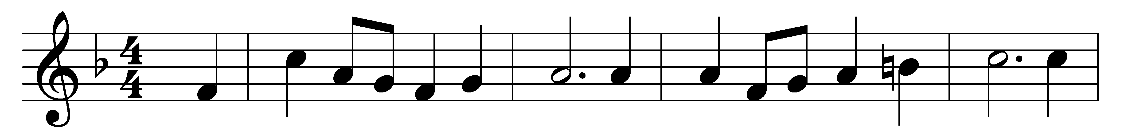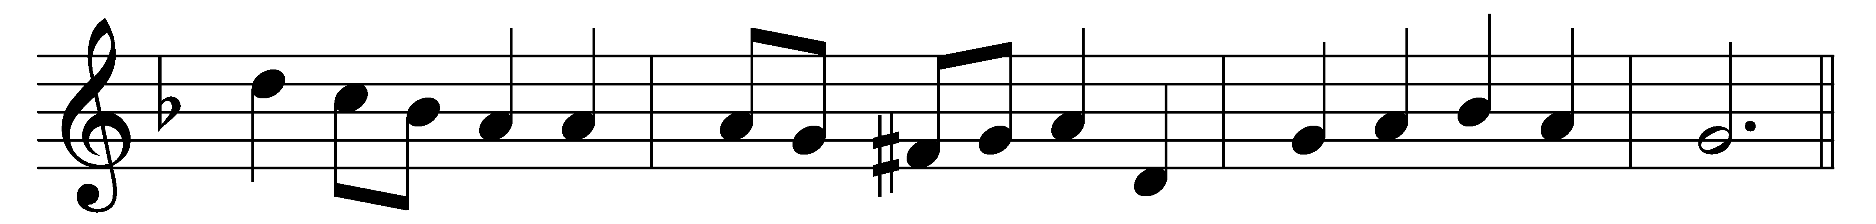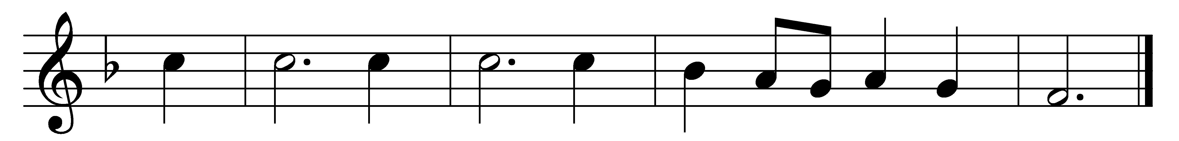

Rejoice, ye pure in heart!
Rejoice, give thanks, and sing!
Your glorious banner wave on high,
the cross of Christ your King.
(Refrain:) Rejoice, rejoice,
rejoice, give thanks, and sing.

With all the angel choirs,
with all the saints of earth,
pour out the strains of joy and bliss,
true rapture, noblest mirth. (Refrain)

Your clear hosannas raise,
and alleluias loud;
while answering echoes upward float,
like wreaths of incense cloud. (Refrain)

Yes, on through life’s long path,
still chanting as ye go,
from youth to age, by night and day,
in gladness and in woe. (Refrain)

Still lift your standard high,
still march in firm array,
as warriors through the darkness toil,
till dawns the golden day. (Refrain)

At last the march shall end;
the wearied ones shall rest;
the pilgrims find their Father’s house,
Jerusalem the blest. (Refrain)

Then on, ye pure in heart!
Rejoice, give thanks, and sing!
Your glorious banner wave on high,
the cross of Christ your King. (Refrain)

Words: Edward Hayes Plumptre (1821-1891)
Music: Arthur Henry Messiter (1834-1916)

