Lead on, O King eternal Hymnal 1982 no. 555 Melody: Lancashire 7 6. 7 6. D.
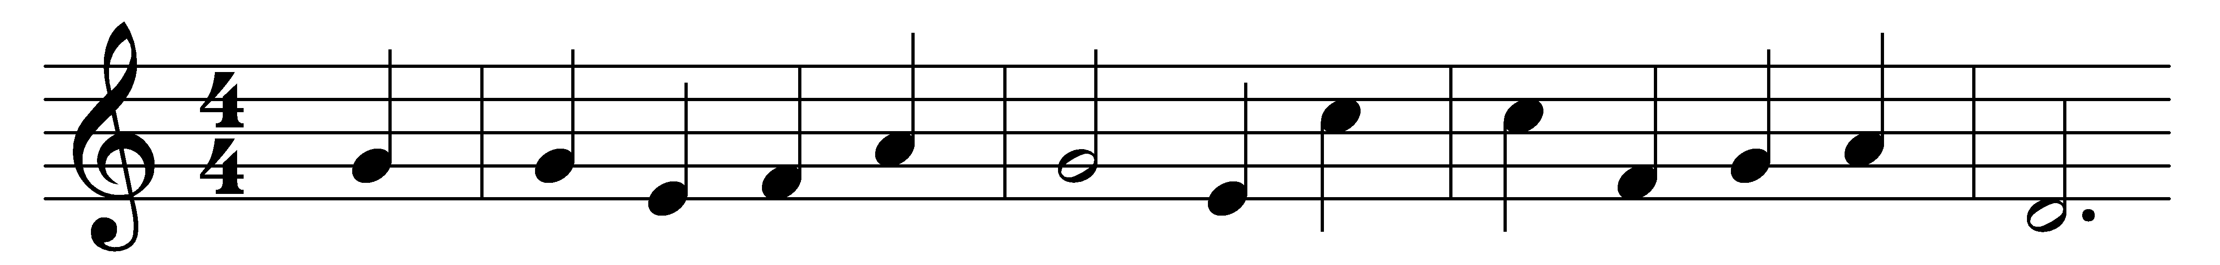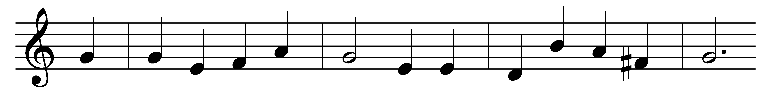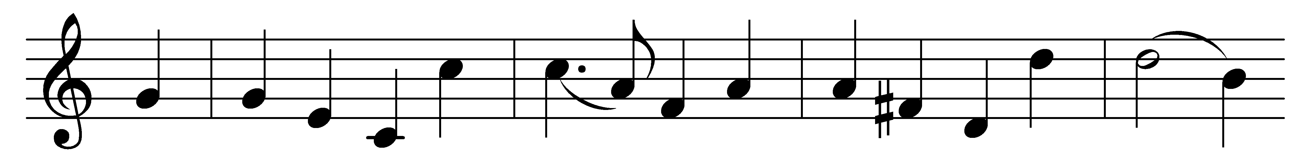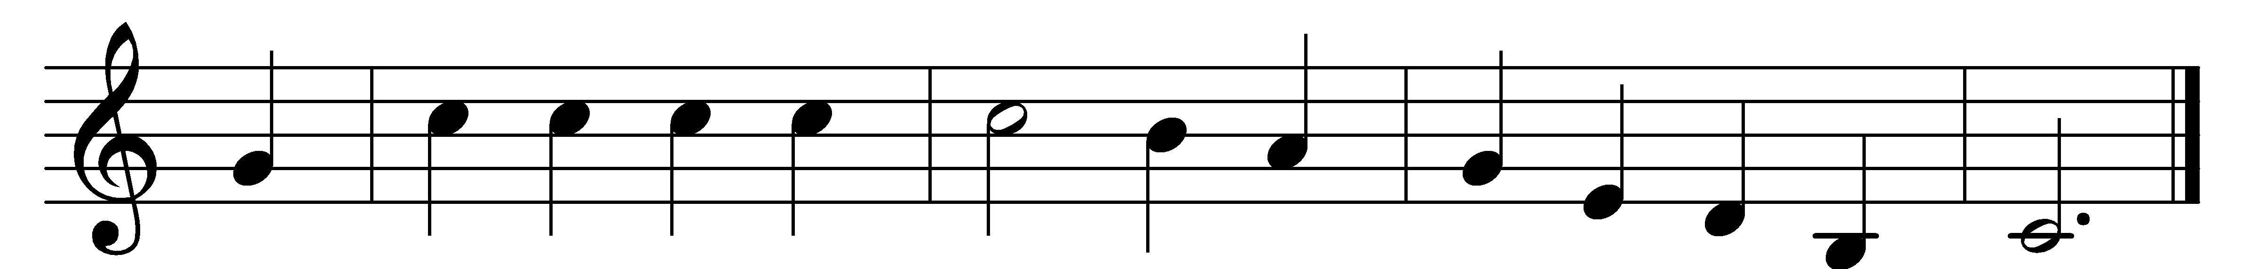

Lead on, O King eternal,
the day of march has come;
henceforth in fields of conquest
thy tents shall be our home:
through days of preparation
thy grace has made us strong,
and now, O King eternal,
we lift our battle song.

Lead on, O King eternal,
till sin’s fierce war shall cease,
and holiness shall whisper
the sweet amen of peace;
for not with swords loud clashing,
nor roll of stirring drums,
but deeds of love and mercy,
the heavenly kingdom comes.

Lead on, O King eternal:
we follow, not with fears;
for gladness breaks like morning
where-e’er thy face appears.
Thy cross is lifted o’er us;
we journey in its light:
the crown awaits the conquest;
lead on, O God of might!

Words: Ernest Warburton Shurtleff (1862-1917)
Music: Henry Thomas Smart (1813-1879)

