’Tis the gift to be simple Hymnal 1982 no. 554 Melody: Simple Gifts Irregular metre
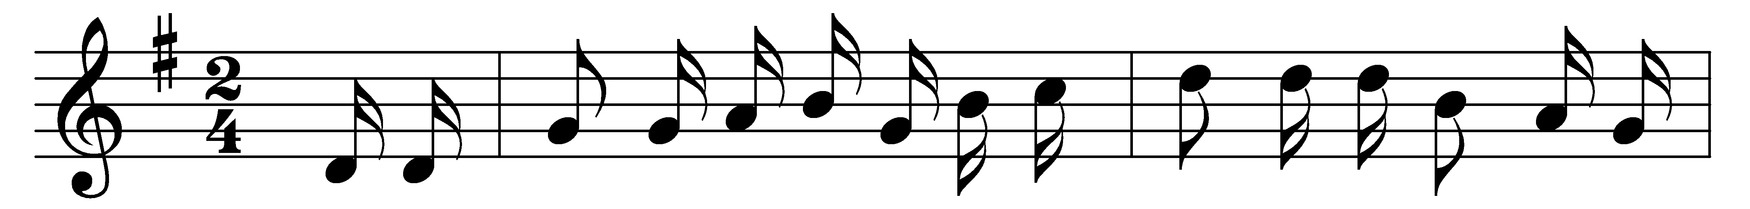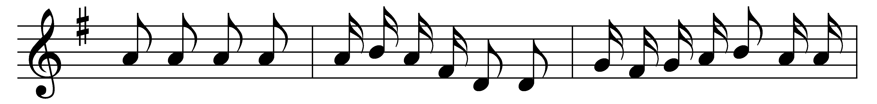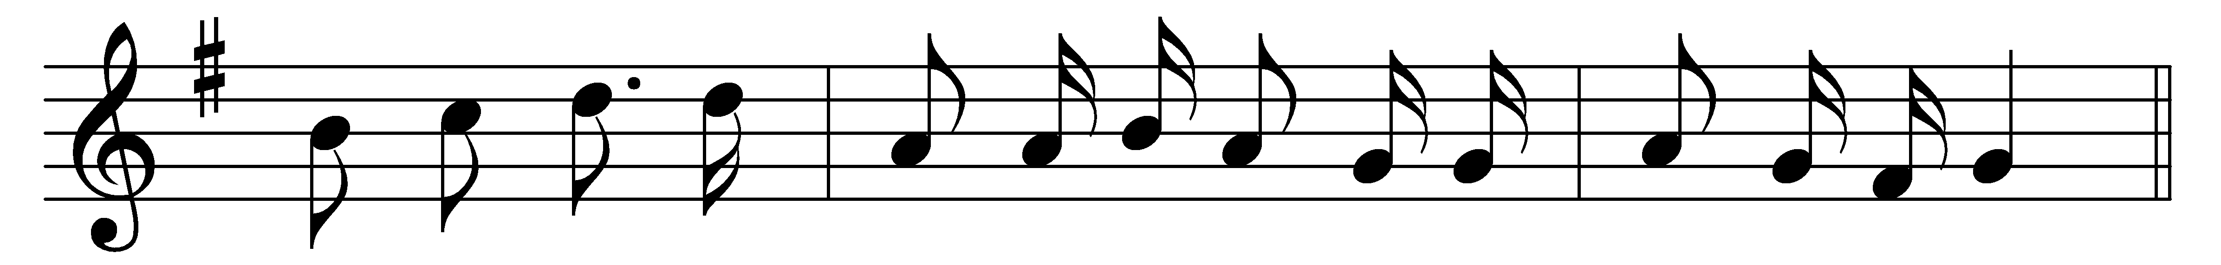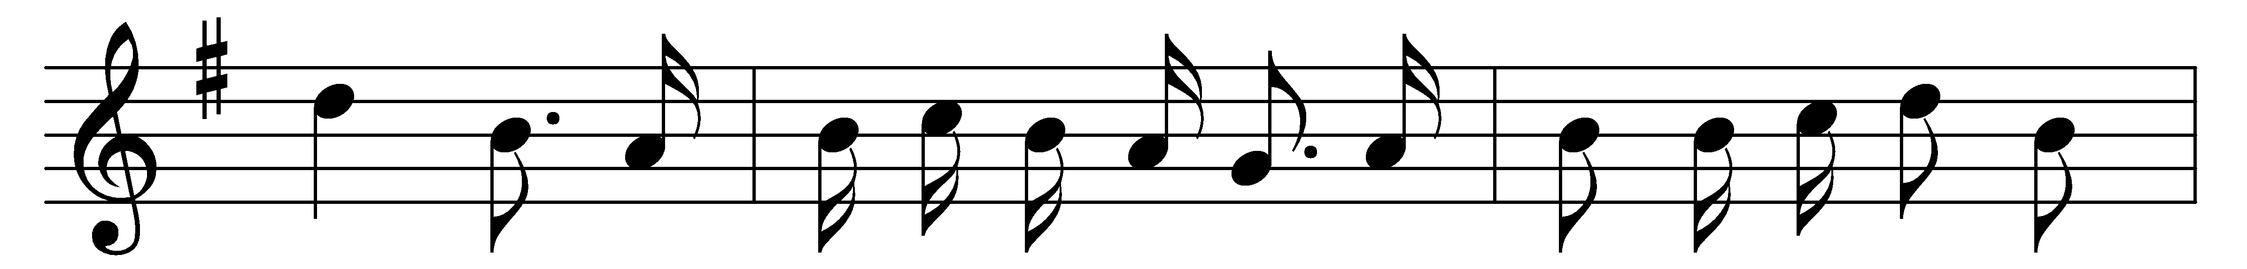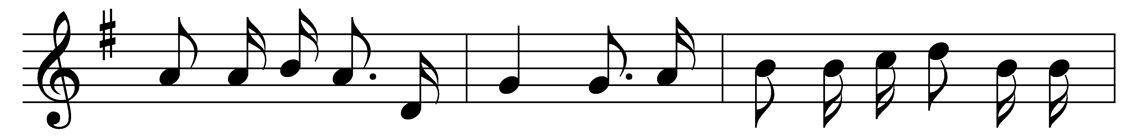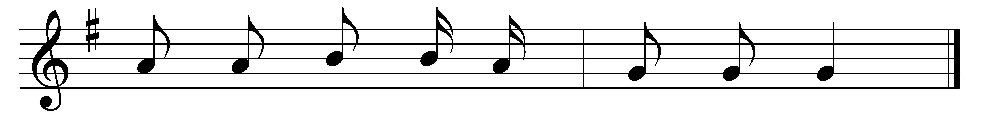

’Tis the gift to be simple,
’tis the gift to be free,
’tis the gift to come down
where we ought to be,
and when we find ourselves in the place just right,
’twill be in the valley of love and delight.
When true simplicity is gained
to bow and to bend we shan’t be ashamed,
to turn, turn, will be our delight
till by turning, turning we come round right.

Words: Shaker song, 18th century
Music: Attributed to Joseph Brackett (1797-1882)

