Rise up, ye saints of God! Hymnal 1982 no. 551 Melody: Festal Song S.M.

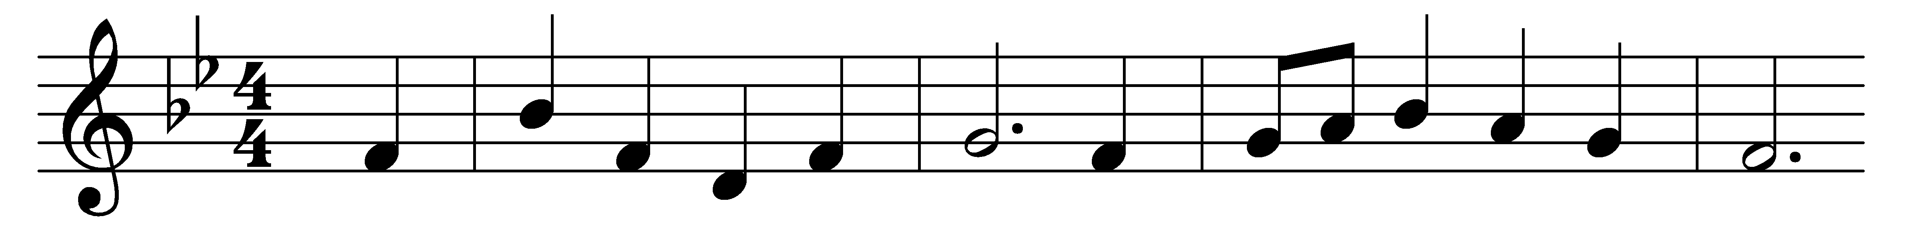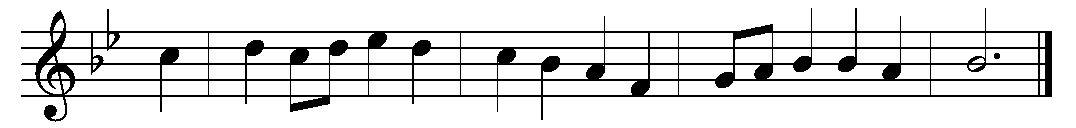

Rise up, ye saints of God!

Have done with lesser things,

give heart and soul and mind and strength

to serve the King of kings.

Rise up, ye saints of God!

His kingdom tarries long:

Lord, bring the day of truth and love

And end the night of wrong.

Lift high the cross of Christ!

Tread where his feet have trod;

and quickened by the Spirit’s power,

rise up, ye saints of God!

Words: William Pierson Merrill (1867-1954)

Music: William Henry Walter (1825-1893)