Awake, my soul, stretch every nerve Hymnal 1982 no. 546 Melody: Siroë 8 6. 8 6 6.

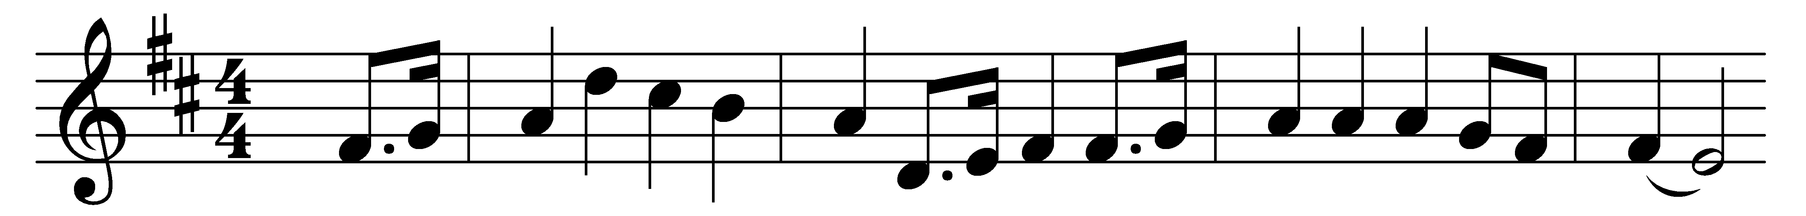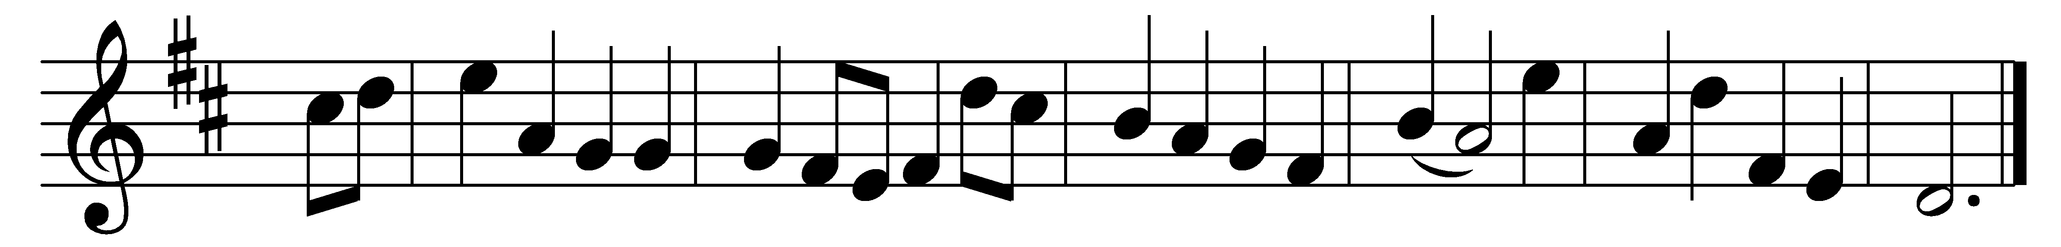

Awake, my soul, stretch every nerve,
and press with vigor on;
a heavenly race demands thy zeal,
and an immortal crown,
and an immortal crown.

A cloud of witnesses around
hold thee in full survey;
forget the steps already trod,
and onward urge thy way,
and onward urge thy way.

’Tis God’s all-animating voice
that calls thee from on high;
’tis his own hand presents the prize
to thine aspiring eye,
to thine aspiring eye.

Then wake, my soul, stretch every nerve,
and press with vigor on;
a heavenly race demands thy zeal,
and an immortal crown,
and an immortal crown.

Words: Philip Doddridge (1702-1751)
Music: George Frideric Handel (1685-1759), adapted in Melodia Sacra, 1815

