O Zion, haste, thy mission high fulfilling Hymnal 1982 no. 539
Melody: Tidings 11 10. 11 10. with refrain
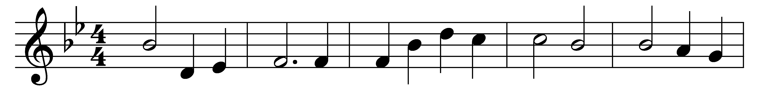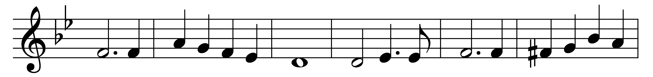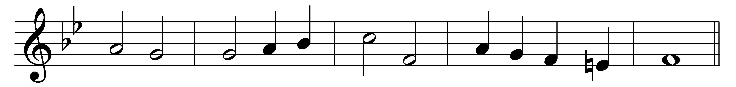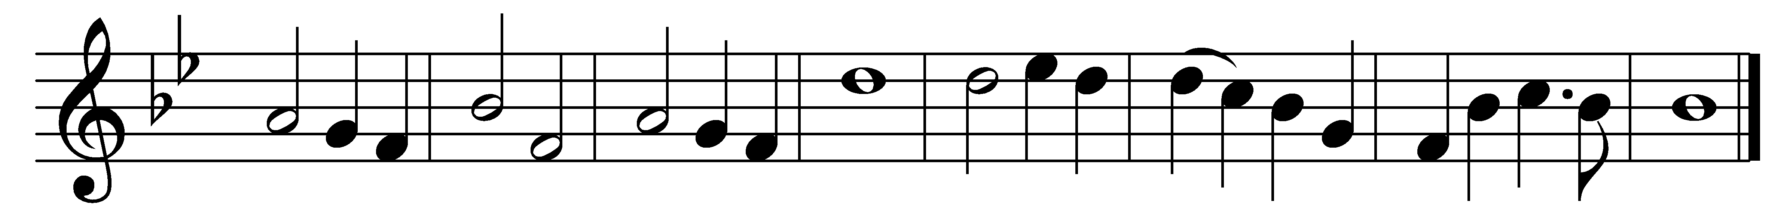

O Zion, haste, thy mission high fulfilling,
to tell to all the world that God is Light;
that he who made all nations is not willing
one soul should fail to know his love and might.
(Refrain:) Publish glad tidings: tidings of peace,
tidings of Jesus, redemption and release.

Proclaim to every people, tongue, and nation
that God, in whom they live and move, is Love;
tell how he stooped to save his lost creation,
and died on earth that all might live above. (Refrain)

Send heralds forth to bear the message glorious;
give of thy wealth to speed them on their way;
pour out thy soul for them in prayer victorious
till God shall bring his kingdom’s joyful day. (Refrain)

He comes again! O Zion, ere thou meet him,
make known to every heart his saving grace;
let none whom he hath ransomed fail to greet him,
through thy neglect, unfit to see his face. (Refrain)

Words: Mary Ann Thomson (1834-1923)
Music: James Walch (1837-1901)

