God of mercy, God of grace Hymnal 1982 no. 538 Melody: Lucerna Laudoniae 7 7. 7 7. 7 7.
Words from AMNS
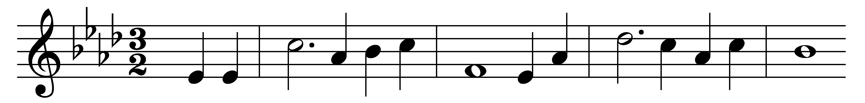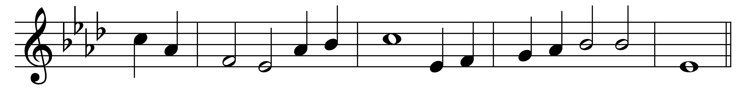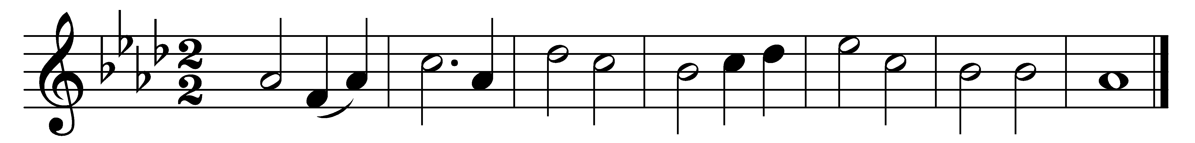

God of mercy, God of grace,
show the brightness of thy face;
shine upon us, Saviour, shine,
fill thy Church with light divine;
and thy saving health extend
unto earth’s remotest end.
Let the people praise thee, Lord;
be by all that live adored;
let the nations shout and sing
glory to their Saviour King;
at thy feet their tribute pay,
and thy holy will obey.
Let the people praise thee, Lord;
earth shall then her fruits afford;
God to man his blessing give,
man to God devoted live;
all below, and all above,
one in joy and light and love.

Words: Henry Francis Lyte (1793-1847)
Music: David Evans (1874-1948)

