Christ for the world we sing! Hymnal 1982 no. 537 Melody: Moscow 6 6 4. 6 6 6 4.
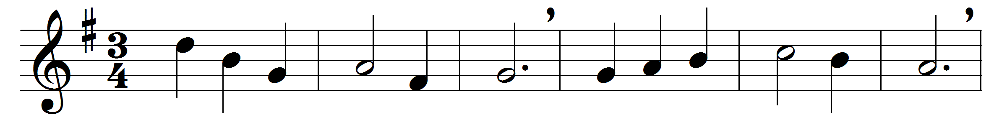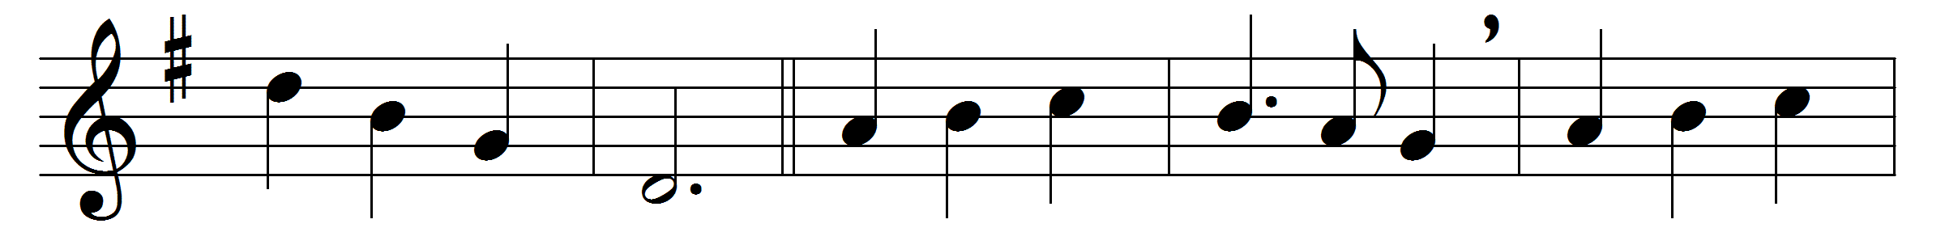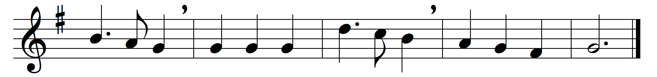

Christ for the world we sing!
The world to Christ we bring
with loving zeal;
the poor, and them that mourn,
the faint and overborne,
sin-sick and sorrow-worn,
whom Christ doth heal.

Christ for the world we sing!
The world to Christ we bring
with fervent prayer;
the wayward and the lost,
by restless passions tossed,
redeemed at countless cost
from dark despair.

Christ for the world we sing!
The world to Christ we bring
with one accord;
with us the work to share,
with us reproach to dare,
with us the cross to bear,
for Christ our Lord.

Christ for the world we sing!
The world to Christ we bring
with joyful song;
the newborn souls, whose days,
reclaimed from error’s ways,
inspired with hope and praise,
to Christ belong.

Words: Samuel Wolcott (1813-1886)
Music: Felice de Giardini (1716-1796)

