How wondrous and great Hymnal 1982 no. 532 Melody: Old 104th 10 10. 11 11.
Melody from AMNS, British spelling
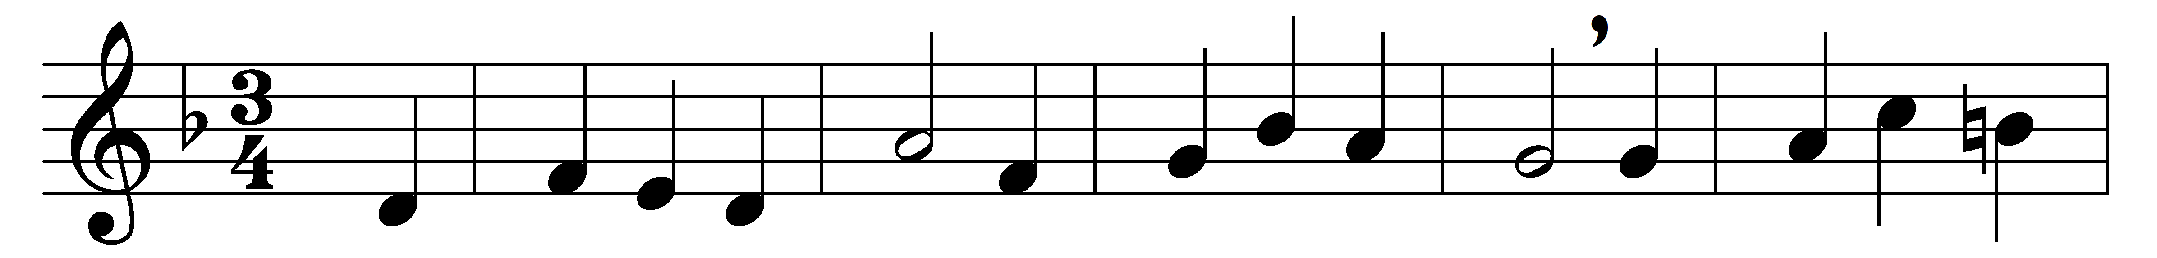
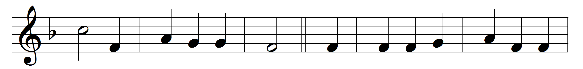
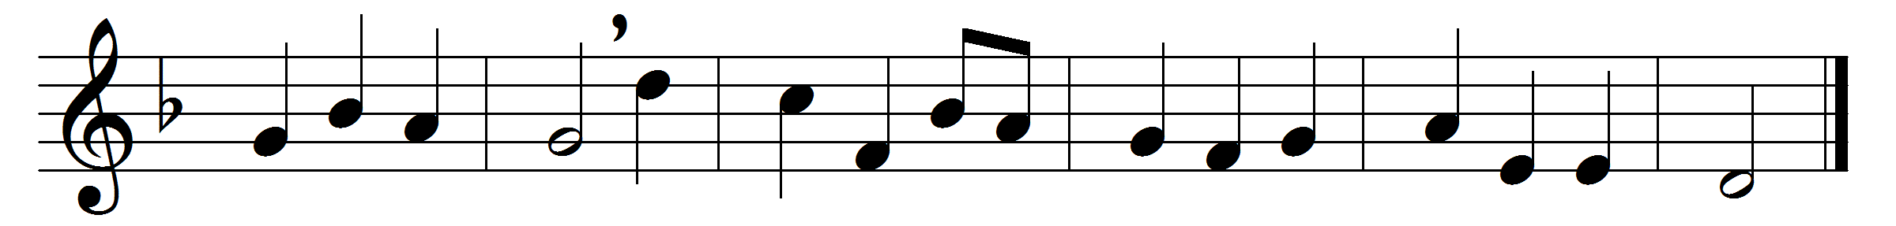

How wondrous and great thy works, God of praise!
How just, King of saints, and true are thy ways!
O who shall not fear thee, and honour thy Name?
Thou only art holy, thou only supreme.

To nations of earth thy light shall be shown;
their worship and vows shall come to thy throne:
thy truth and thy judgements shall spread all abroad,
till earth’s every people confess thee their God.

Words: Henry Ustick Onderdonk (1759-1858)
Music: Thomas Ravenscroft (c. 1592-c. 1635)

