O Spirit of the living God Hymnal 1982 no. 531 Melody: Melcombe L.M.
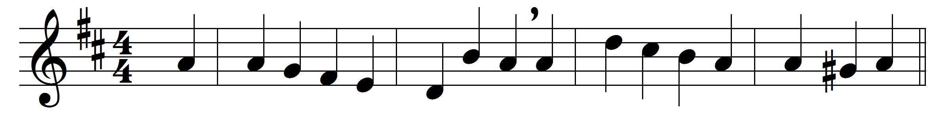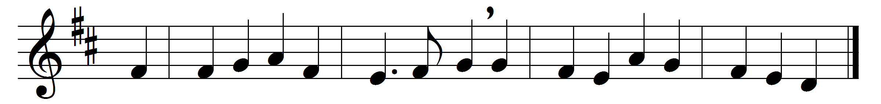

O Spirit of the living God,
in all thy plenitude of grace,
where’er the foot of man hath trod,
descend on our apostate race.

Give tongues of fire and hearts of love,
to preach the reconciling word;
give power and unction from above,
whene’er the joyful sound is heard.

Be darkness, at thy coming, light;
confusion, order in thy path;
souls without strength inspire with might,
bid mercy triumph over wrath.

Convert the nations! far and nigh
the triumph of the cross record;
the Name of Jesus glorify,
till every people call him Lord.

Words: James Montgomery (1771-1854)
Music: Samuel Webbe the elder (1740-1816)

