In Christ there is no East or West Hymnal 1982 no. 529 Melody: McKee C.M.
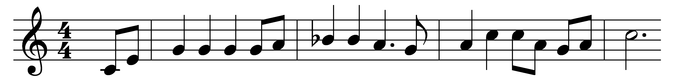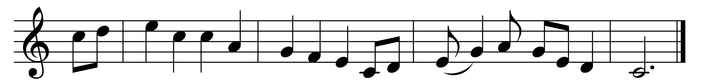

In Christ there is no East or West,
in him no South or North,
but one great fellowship of love
throughout the whole wide earth.

Join hands, disciples of the faith,
whate’er your race may be!
Who serves my Father as his child
is surely kin to me.

In Christ now meet both East and West,
in him meet South and North,
all Christly souls are one in him,
throughout the whole wide earth.

Words: John Oxenham (1852-1941)
Music: Afro-American spiritual, adapted and harmonised by Harry T. Burleigh (1866-1949)

