Let saints on earth in concert sing Hymnal 1982 no. 526 Melody: Dundee C.M.
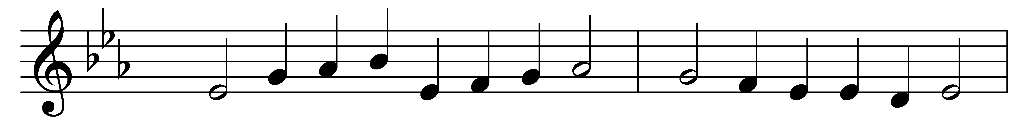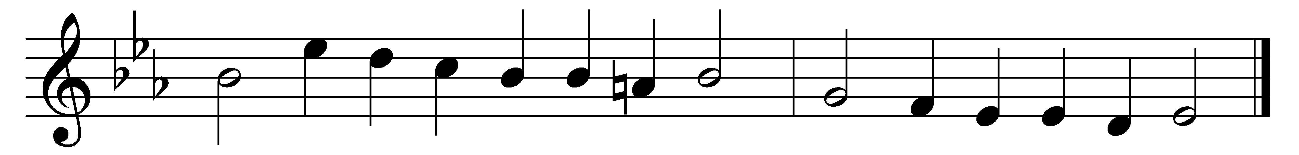

Let saints on earth in concert sing
with those whose work is done;
for all the servants of our King
in heaven and earth are one.

One family we dwell in him,
one Church, above, beneath,
though now divided by the stream,
the narrow stream of death.

One army of the living God,
to his command we bow;
part of the host have crossed the flood,
and part are crossing now.

E’en now by faith we join our hands
with those that went before,
and greet the ever-living bands
on the eternal shore.

Jesus, be thou our constant Guide;
then, when the word is given,
bid Jordan’s narrow stream divide,
and bring us safe to heaven.

Words: Charles Wesley (1707-1788)
Music: Melody from Psalms (Edinburgh, 1615), harmony by Thomas Ravenscroft (1592?-1635?)

