I love thy kingdom, Lord Hymnal 1982 no. 524 Melody: St Thomas S.M.
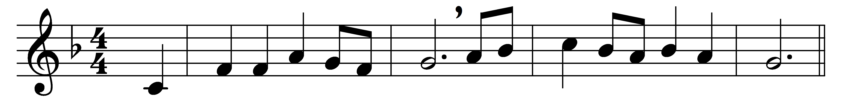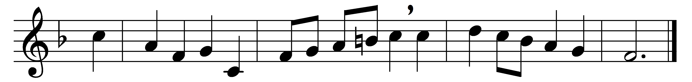

I love thy kingdom, Lord,
the house of thine abode,
the Church our blest Redeemer saved
with his own precious blood.

For her my tears shall fall;
for her my prayers ascend;
to her my cares and toils be given,
till toils and cares shall end.

Beyond my highest joy
I prize her heavenly ways,
her sweet communion, solemn vows,
her hymns of love and praise.

Jesus, thou friend divine,
our Savior and our King,
thy hand from every snare and foe
shall great deliverance bring.

Sure as thy truth shall last,
to Zion shall be given
the brightest glories earth can yield,
and brighter bliss of heaven.

Words: Timothy Dwight (1725-1817)
Music: Melody by Aaron Williams (1731-1776), harmony by Lowell Mason (1792-1872)

