Spirit divine, attend our prayers Hymnal 1982 no. 509 Melody: Nun danket all C.M.
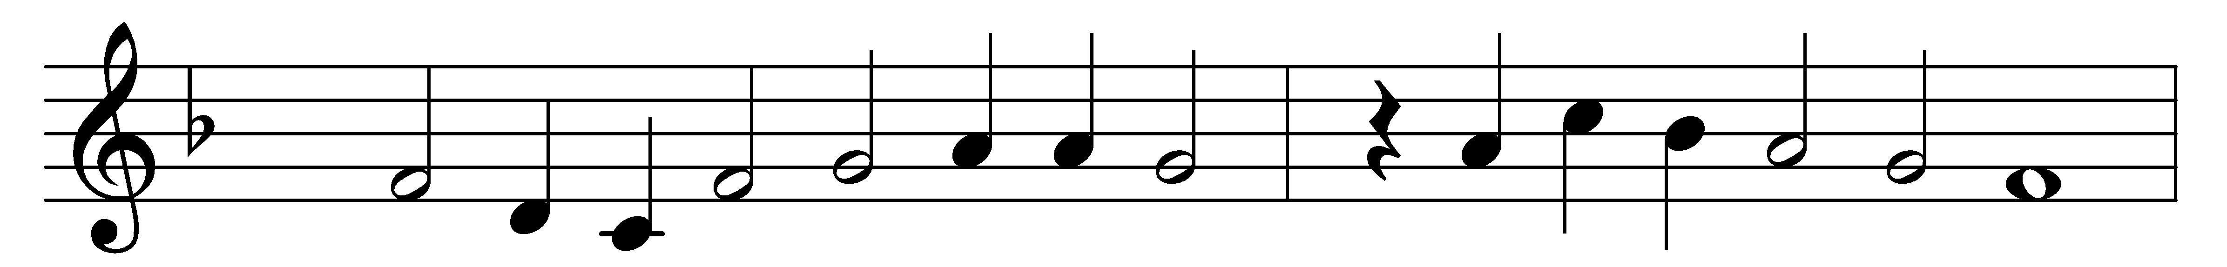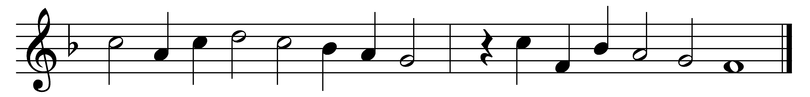

Spirit divine, attend our prayers,
and make this house thy home;
descend with all thy gracious powers,
O come, great Spirit, come!

Come as the light; to us reveal
our emptiness and woe,
and lead us in those paths of life
whereon the righteous go.

Come as the fire, and purge our hearts
like sacrificial flame;
let our whole soul an offering be
to our Redeemer’s Name.

Come as the dove, and spread thy wings,
the wings of peaceful love;
and let thy Church on earth become
blest as the Church above.

Spirit divine, attend our prayers;
make a lost world thy home;
descend with all thy gracious powers;
O come, great Spirit, come!

Words: Andrew Reed (1787-1862)
Music: Melody from Praxis pietatis melica, 1647

