Creator Spirit, by whose aid Hymnal 1982 no. 500 Melody: Surrey 8 8. 8 8. 8 8.
British spelling
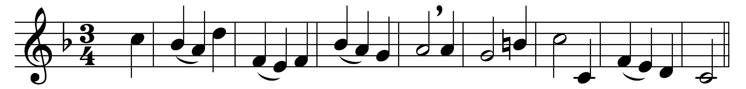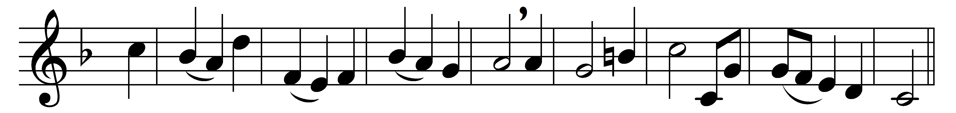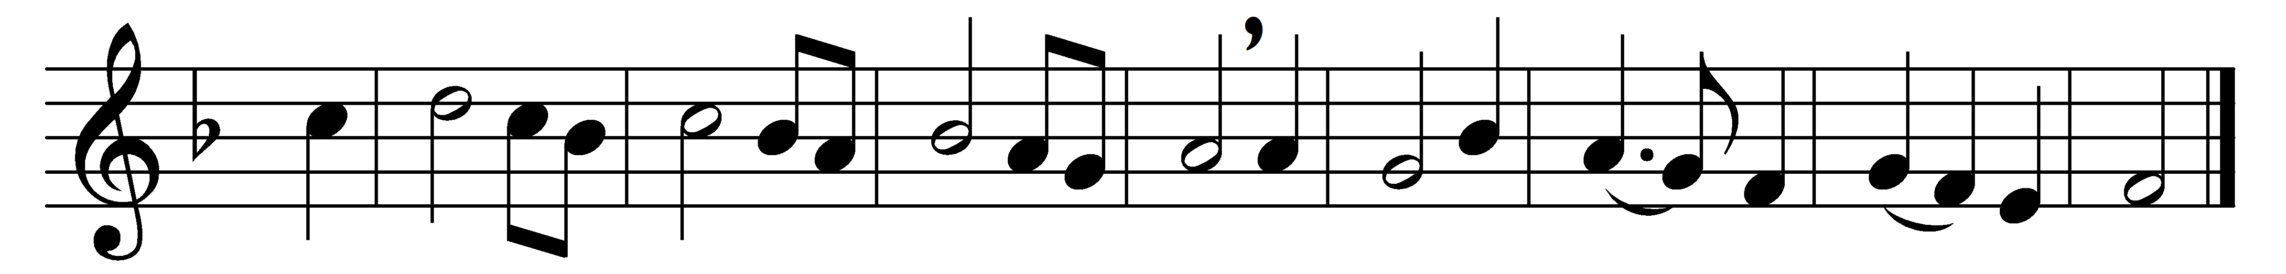

Creator Spirit, by whose aid
the world’s foundations first were laid,
come, visit every humble mind;
come, pour thy joys on humankind;
from sin and sorrow set us free,
and make thy temples worthy thee.

O Source of uncreated light,
the Father’s promised Paraclete,
thrice holy Fount, thrice holy Fire,
our hearts with heavenly love inspire;
come, and thy sacred unction bring
to sanctify us while we sing.

Plenteous of grace, come from on high,
rich in thy sevenfold energy;
make us eternal truth receive,
and practise all that we believe;
give us thyself, that we may see
the Father and the Son by thee.

Words: John Dryden (1631-1700), translation of Veni Creator Spiritus
Music: Henry Carey (c. 1690-1743)

