Beneath the cross of Jesus Hymnal 1982 no. 498 Melody: St Christopher 7 6. 8 6. 8 6. 8 6.
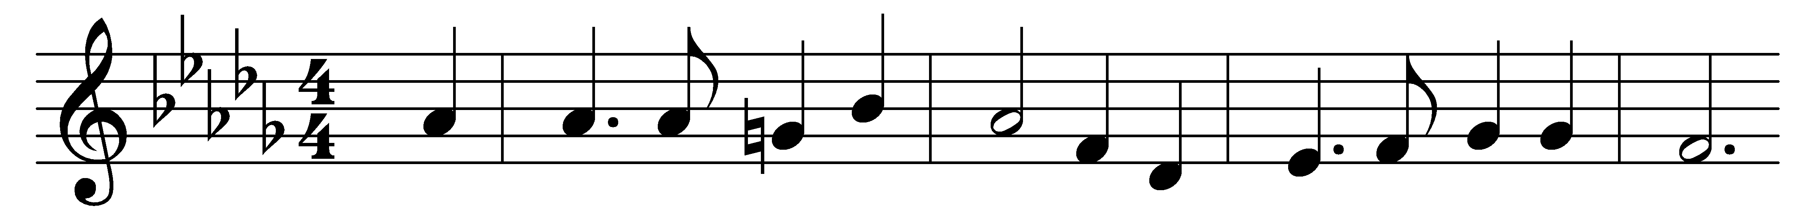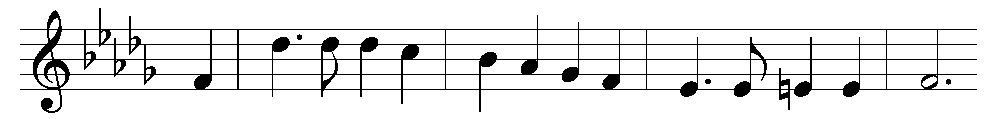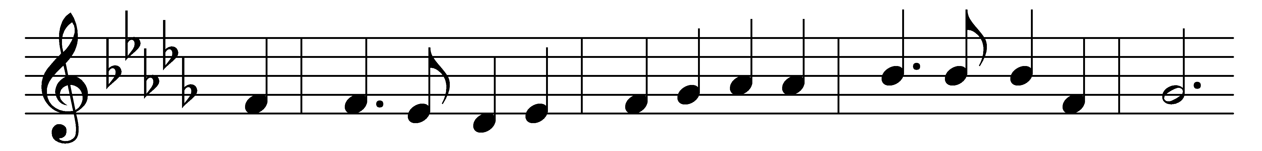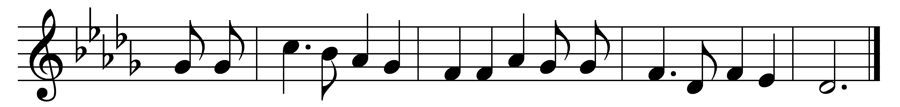

Beneath the cross of Jesus
I fain would take my stand,
the shadow of a mighty rock
within a weary land,
a home within the wilderness,
a rest upon the way,
from the burning of the noontide heat
and the burden of the day.

Upon the cross of Jesus
mine eyes at times can see
the very dying form of one
who suffered there for me;
and from my smitten heart with tears
two wonders I confess:
the wonders of redeeming love
and my unworthiness.

I take, O cross, thy shadow
for my abiding place;
I ask no other sunshine than
the sunshine of his face;
content to let my pride go by,
to know no gain nor loss,
my sinful self my only shame,
my glory all the cross.

Words: Elizabeth Cecilia Clephane (1830-1869)
Music: Frederick Charles Maker (1844-1927)

