How bright appears the Morning Star Hymnal 1982 no. 496
Melody: Wie schön leuchtet Irregular metre
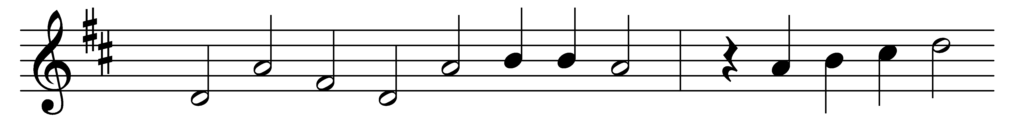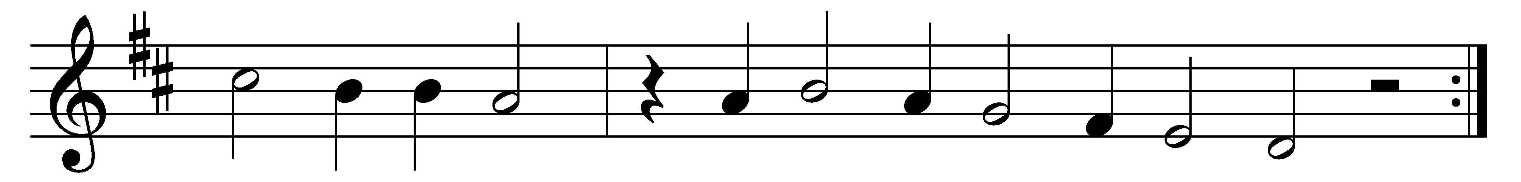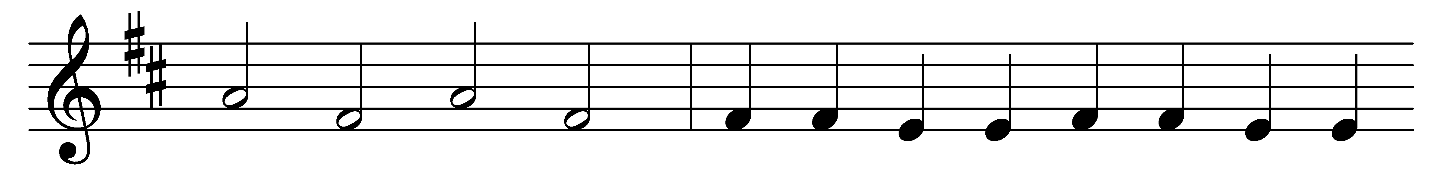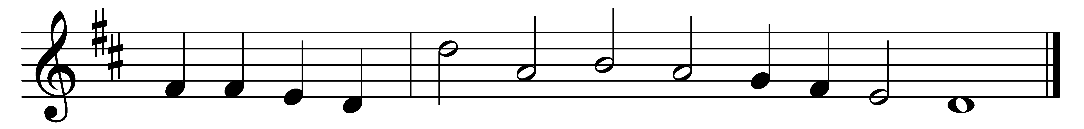
How bright appears the Morning Star,
with mercy beaming from afar;
the host of heaven rejoices;
O righteous Branch, O Jesse’s Rod!
Thou Son of Man and Son of God!
We, too, will lift our voices:
Jesus, Jesus!
Holy, holy, yet most lowly,
draw thou near us;
great Emmanuel, come and hear us.

Though circled by the hosts on high,
he deigned to cast a pitying eye
upon his helpless creature;
the whole creation’s Head and Lord,
by highest seraphim adored,
assumed our very nature;
Jesus, grant us,
through thy merit, to inherit
thy salvation;
hear, O hear our supplication.

Rejoice, ye heavens; thou earth, reply;
with praise, ye sinners, fill the sky,
for this his Incarnation.
Incarnate God, put forth thy power,
ride on, ride on, great Conqueror,
till all know thy salvation.
Amen, amen!
Alleluia, alleluia!
Praise be given
evermore, by earth and heaven.

Words: William Mercer (1811-1873) after Philipp Nicolai (1556-1608)
Music: Melody attributed to Philipp Nicolai (1556-1608), harmony by Johann Herman Schein (1586-1630)

