Hail, thou once despised Jesus! Hymnal 1982 no. 495 Melody: In Babilone 8 7. 8 7. D.

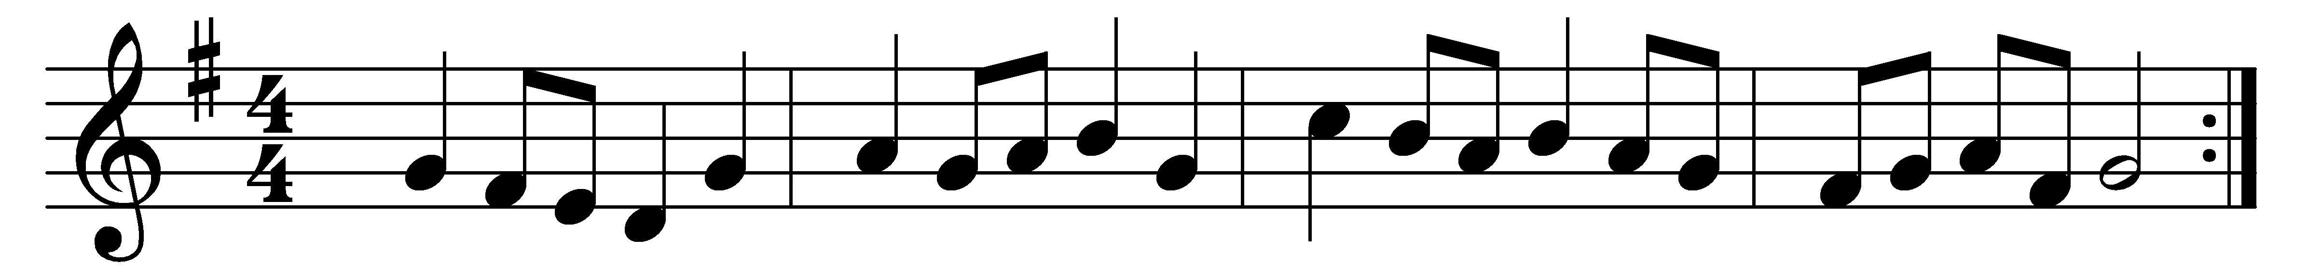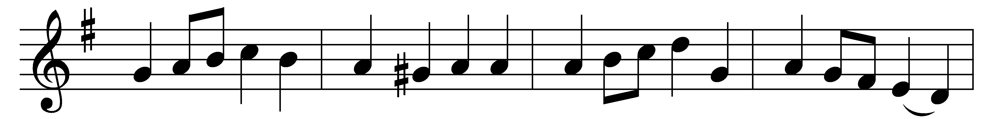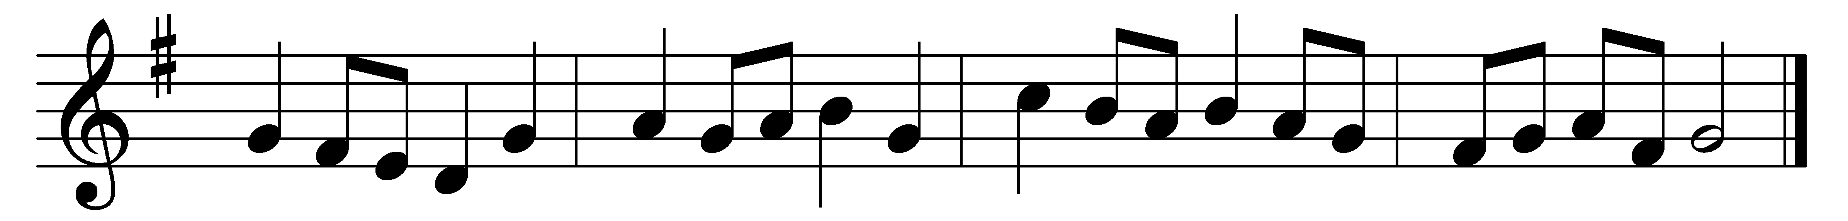

Hail, thou once despisèd Jesus!
Hail, thou Galilean King!
Thou didst suffer to release us;
thou didst free salvation bring.
Hail, thou universal Savior,
bearer of our sin and shame!
By thy merit we find favor:
life is given through thy Name.

Paschal Lamb, by God appointed,
all our sins on thee were laid:
by almighty love anointed,
thou hast full atonement made.
All thy people are forgiven
through the virtue of thy blood:
opened is the gate of heaven,
reconciled are we with God.

Jesus, hail! enthroned in glory,
there for ever to abide;
all the heavenly hosts adore thee,
seated at thy Father’s side.
There for sinners thou art pleading:
there thou dost our place prepare;
ever for us interceding,
till in glory we appear.

Worship, honor, power, and blessing
thou art worthy to receive;
highest praises, without ceasing,
right it is for us to give.
Help, ye bright angelic spirits,
all your noblest anthems raise;
help to sing our Savior’s merits,
help to chant Emmanuel’s praise!

Words: John Bakewell (1721-1819) and Martin Madan (1726-1790)
Music: Melody from Oude en Nieuwe Hollantse Boerenlities en Contradansen, 1710

