O for a thousand tongues to sing Hymnal 1982 no. 493 Melody: Azmon C.M.
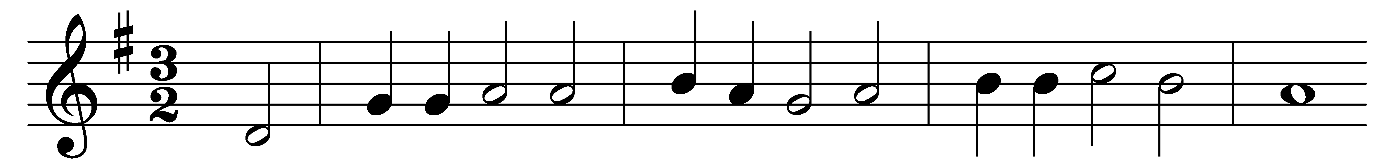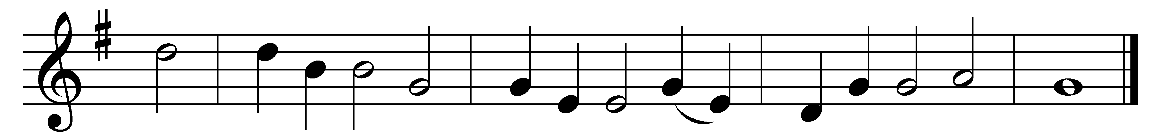

O for a thousand tongues to sing
my dear Redeemer’s praise,
the glories of my God and King,
the triumphs of his grace!

My gracious Master and my God,
assist me to proclaim
and spread through all the earth abroad
the honors of thy Name.

Jesus! the Name that charms our fears
and bids our sorrows cease;
’tis music in the sinner’s ears,
’tis life and health and peace.

He speaks; and, listening to his voice,
new life the dead receive,
the mournful broken hearts rejoice,
the humble poor believe.

Hear him, ye deaf; ye voiceless ones,
your loosened tongues employ;
ye blind, behold, your Savior comes;
and leap, ye lame, for joy!

Glory to God and praise and love
be now and ever given
by saints below and saints above,
the Church in earth and heaven.

Words: Charles Wesley (1707-1788)
Music: Carl Gotthilf Gläser (1784-1829), adapted and arranged by Lowell Mason (1792-1872)

