Praise the Lord through every nation 1982 no. 484 Melody: Wachet auf Irregular metre

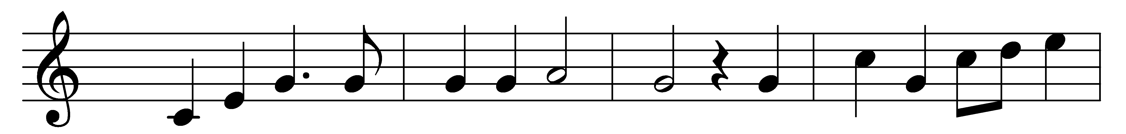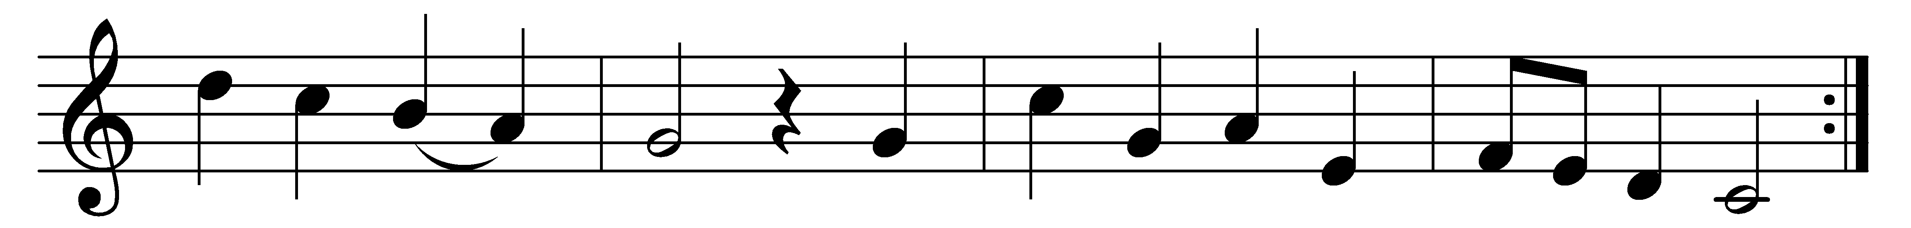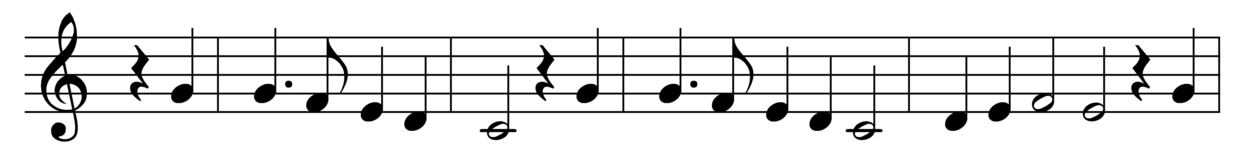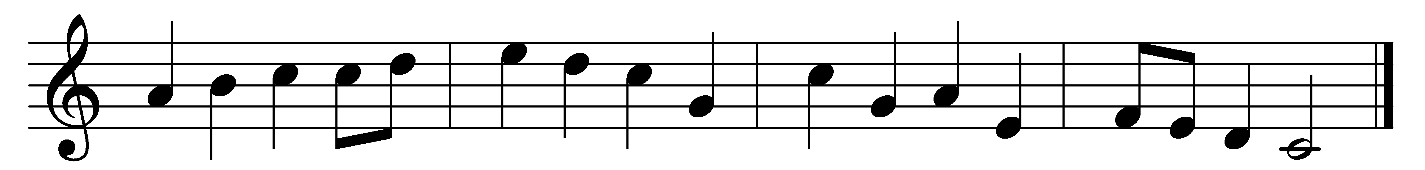

Praise the Lord through every nation;
his holy arm hath wrought salvation;
exalt him on his Father’s throne.
Praise your King, ye Christian legions,
who now prepares in heavenly regions
unfailing mansions for his own:
with voice and minstrelsy
extol his majesty:
Alleluia!
His praise shall sound all nature round,
and hymns on every tongue abound.

Jesus, Lord, our Captain glorious,
o’er sin, and death, and hell victorious,
wisdom and might to thee belong:
we confess, proclaim, adore thee;
we bow the knee, we fall before thee;
thy love henceforth shall be our song.
The cross meanwhile we bear,
the crown ere-long to wear:
Alleluia!
Thy reign extend world without end;
let praise from all to thee ascend.

Words: Rhijnvis Feith (1753-1824), paraphrased by James Montgomery (1771-1854)
Music: Melody by Hans Sachs (1494-1576), adapted by Philipp Nicolai (1556-1608), arranged and harmonised by Johann Sebastian Bach (1685-1750)

