When Jesus left his Father’s throne Hymnal 1982 no. 480 Melody: Kingsfold D.C.M.
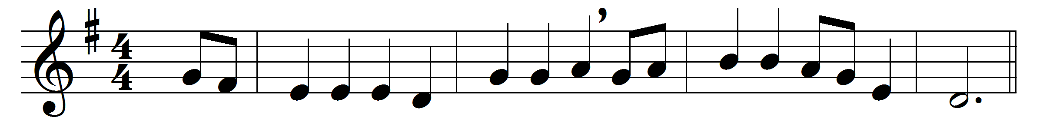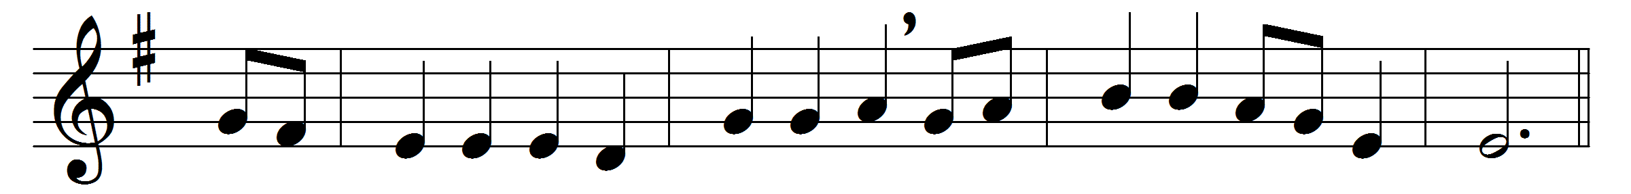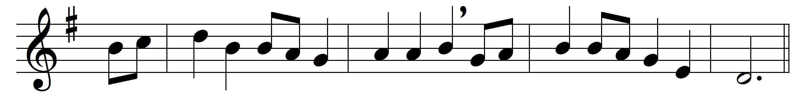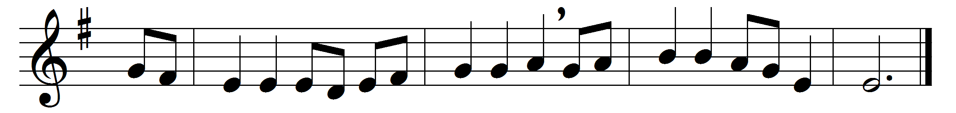

When Jesus left his Father’s throne,
he chose an humble birth;
like us, unhonored and unknown,
he came to dwell on earth.
Like him may we be found below
in wisdom’s path of peace;
like him in grace and knowledge grow
as years and strength increase.

Sweet were his words and kind his look,
when mothers round him pressed;
their infants in his arms he took,
and on his bosom blessed.
Safe from the world’s alluring harms,
beneath his watchful eye,
thus in the circle of his arms
may we for ever lie.

When Jesus into Zion rode,
the children sang around;
for joy they plucked the palms and strowed
their garments on the ground.
Hosanna our glad voices raise,
hosanna to our King!
Should we forget our Savior’s praise,
the stones themselves would sing.

Words: James Montgomery (1771-1854)
Music: English traditional melody

