On this day, the first of days Hymnal 1982 no. 47 Melody: Gott sei Dank 7 7. 7 7.
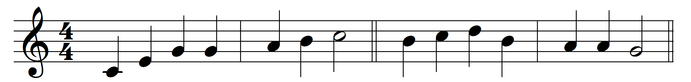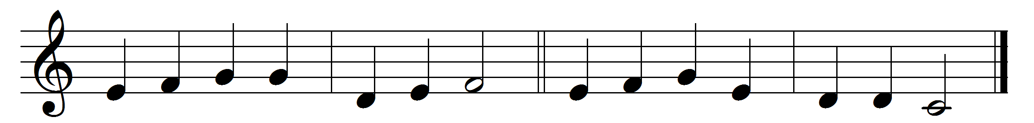

On this day, the first of days,
God the Father’s Name we praise,
who, creation’s Lord and spring,
did the world from darkness bring.

On this day th’ eternal Son
over death his triumph won;
on this day the Spirit came
with his gifts of living flame.

Maker, who didst fashion me
image of thyself to be,
fill me with thy love divine,
let my every thought be thine.

Holy Jesus, may I be
dead and buried here with thee;
and, by love inflamed, arise
unto thee a sacrifice.

Thou, who dost all gifts impart,
shine, blest Spirit, in my heart;
best of gifts, thyself bestow;
make me burn thy love to know.

God, the blessèd Three in One
dwell within my heart alone;
thou dost give thyself to me:
help me give myself to thee.

Words: Latin, translated by Henry Williams Baker (1821-1877)
Music: Melody from Geistreiches Gesangbuch (1704), adapted and harmonised by William Henry Havergal (1793-1870)

