God himself is with us Hymnal 1982 no. 475 Melody: Tysk 668. 668. 666

British spelling

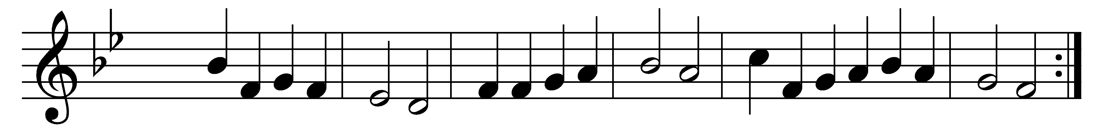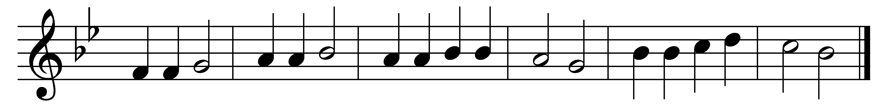

God himself is with us;

let us all adore him,

and with awe appear before him.

God is here within us;

souls in silence fear him,

humbly, fervently draw near him.

Now his own who have known

God, in worship lowly,

yield their spirits wholly.

Gladly, Lord, we offer

thine to be for ever,

soul and life and each endeavour.

Help us to surrender

earth’s deceitful treasures,

pride of life, and sinful pleasures:

thou alone shalt be known

Lord of all our being,

life’s true way decreeing.

Thou pervadest all things;

let thy radiant beauty

light mine eyes to see my duty.

As the tender flowers

eagerly unfold them,

to the sunlight calmly hold them,

so let me quietly

in thy rays imbue me;

let thy light shine through me.

Come, abide within me;

let my soul, like Mary,

be thine earthly sanctuary.

Come, indwelling Spirit,

with transfiguring splendour;

love and honour will I render.

Where I go here below,

let me bow before thee,

know thee, and adore thee.

Words: Gerhardt Tersteegen (1697-1769), translation based on *Hymnal 1940*, v. 3 translated by Henry Sloane Coffin (1877-1954)

Music: From *Psalm- und Choralbuch*, 1719