Souls of men, why will ye scatter Hymnal 1982 no. 470 Melody: Beecher 8 7. 8 7. D.
Words from AMNS
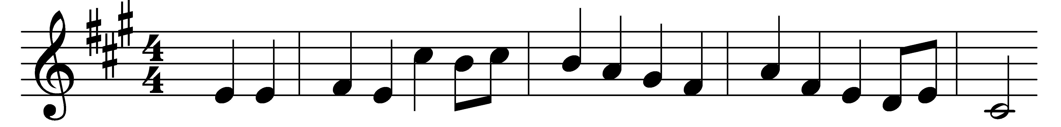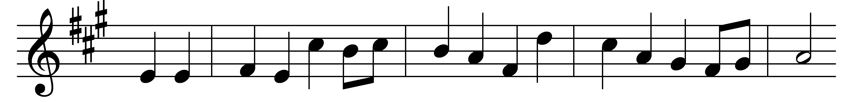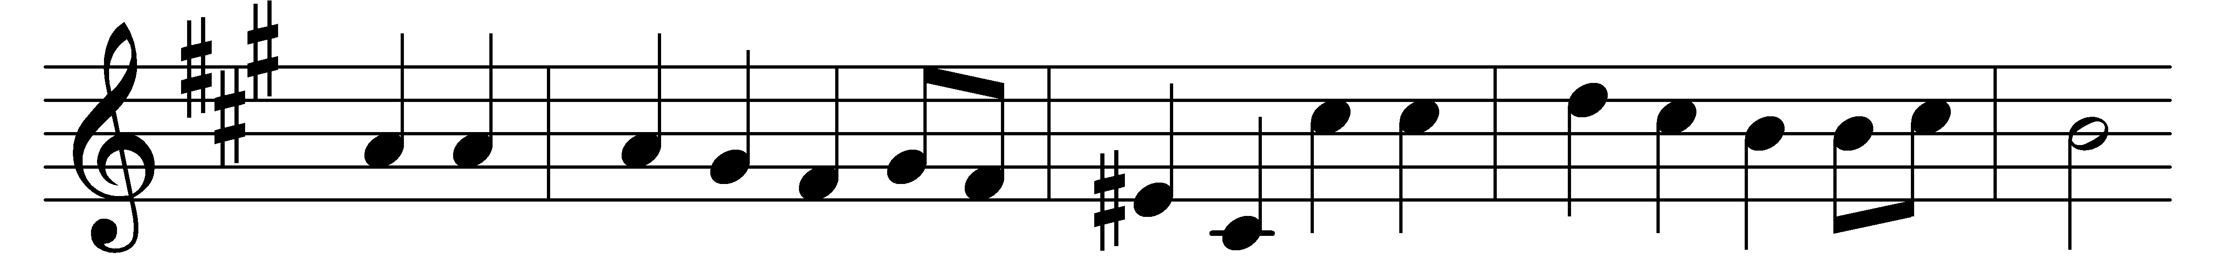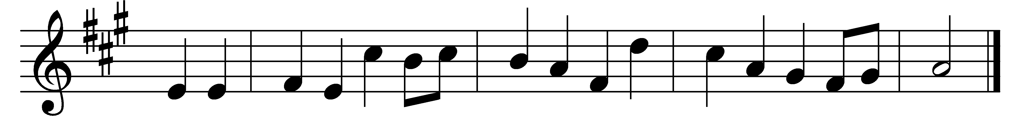

Souls of men, why will ye scatter
like a crowd of frightened sheep?
Foolish hearts, why will ye wander
from a love so true and deep?
Was there ever kindest shepherd
half so gentle, half so sweet,
as the Saviour who would have us
come and gather round his feet?

There’s a wideness in God’s mercy
like the wideness of the sea;
there’s a kindness in his justice
which is more than liberty.
There is no place where earth’s sorrows
are more felt than up in heaven;
there is no place where earth’s failings
have such kindly judgement given.
There is plentiful redemption
in the blood that has been shed;
there is joy for all the members
in the sorrows of the Head.
For the love of God is broader
than the measures of man’s mind;
and the heart of the Eternal
is most wonderfully kind.

Pining souls, come nearer Jesus,
and oh, come not doubting thus,
but with faith that trusts more bravely
his huge tenderness for us.
If our love were but more simple,
we should take him at his word;
and our lives would be all sunshine
in the sweetness of our Lord.

Words: Frederick William Faber (1814-1863)
Music: John Zundel (1815-1882)

