Sing, my soul, his wondrous love Hymnal 1982 no. 467 Melody: St Bees 7 7. 7 7.
British spelling

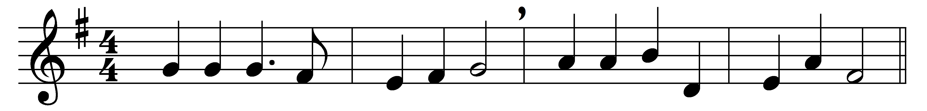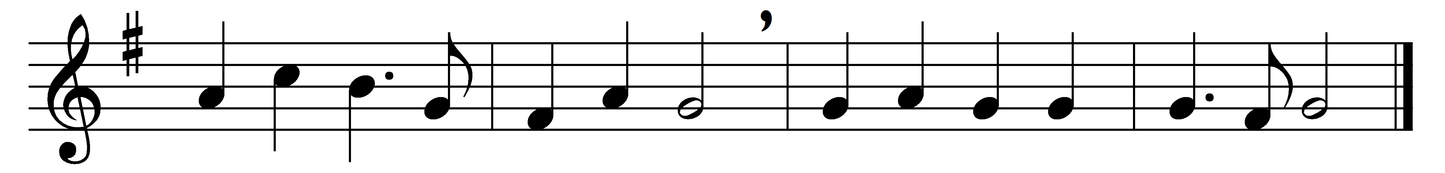

Sing, my soul, his wondrous love,
who, from yon bright throne above,
ever watchful o’er our race,
still to us extends his grace.

Heaven and earth by him were made;
all is by his sceptre swayed;
what are we that he should show
so much love to us below?

God, the merciful and good,
bought us with the Saviour’s blood,
and, to make salvation sure,
guides us by his Spirit pure.

Sing, my soul, adore his Name!
Let his glory be thy theme:
praise him till he calls thee home;
trust his love for all to come.

Words: Anonymous, 1800
Music: John Bacchus Dykes (1823-1876)

