All hail the power of Jesus’ Name! Hymnal 1982 no. 450 Melody: Coronation 8 6. 8 6. 8 6.
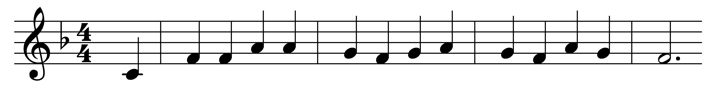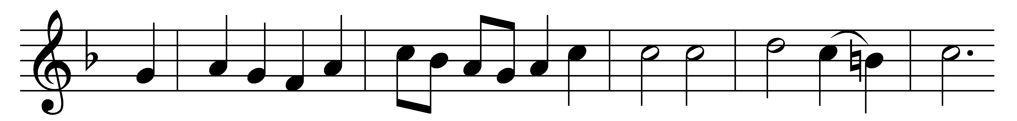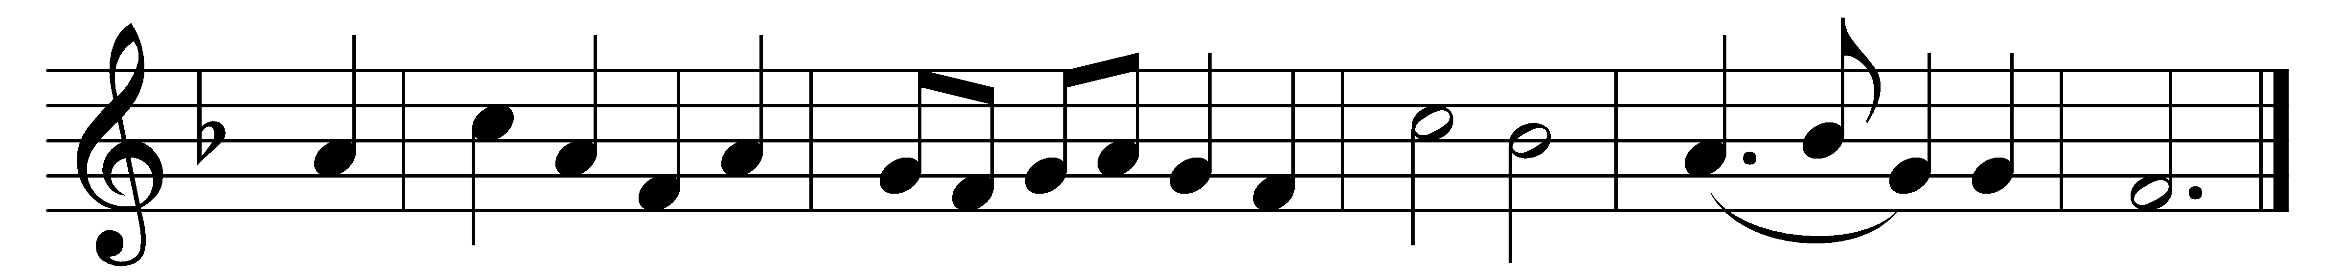

All hail the power of Jesus’ Name!
Let angels prostrate fall;
bring forth the royal diadem,
and crown him Lord of all!
bring forth the royal diadem,
and crown him Lord of all!

Crown him ye martyrs of our God,
who from his altar call:
praise him whose way of pain ye trod,
and crown him Lord of all!
praise him whose way of pain ye trod,
and crown him Lord of all!

Hail him, the Heir of David’s line,
whom David Lord did call,
the God incarnate, Man divine,
and crown him Lord of all!
the God incarnate, Man divine,
and crown him Lord of all!

Ye heirs of Israel’s chosen race,
ye ransomed of the fall,
hail him who saves you by his grace,
and crown him Lord of all!
hail him who saves you by his grace,
and crown him Lord of all!

Sinners, whose love can ne’er forget
the wormwood and the gall,
go, spread your trophies at his feet,
and crown him Lord of all!
go, spread your trophies at his feet,
and crown him Lord of all!

Let every kindred, every tribe,
on this terrestrial ball,
to him all majesty ascribe,
and crown him Lord of all!
to him all majesty ascribe,
and crown him Lord of all!

Words: Edward Perronet (c. 1726-1792)
Music: Oliver Holden (1765-1844)

