What wondrous love is this, O my soul Hymnal 1982 no. 439
Melody: Wondrous Love 12 9. 12. 12 9.
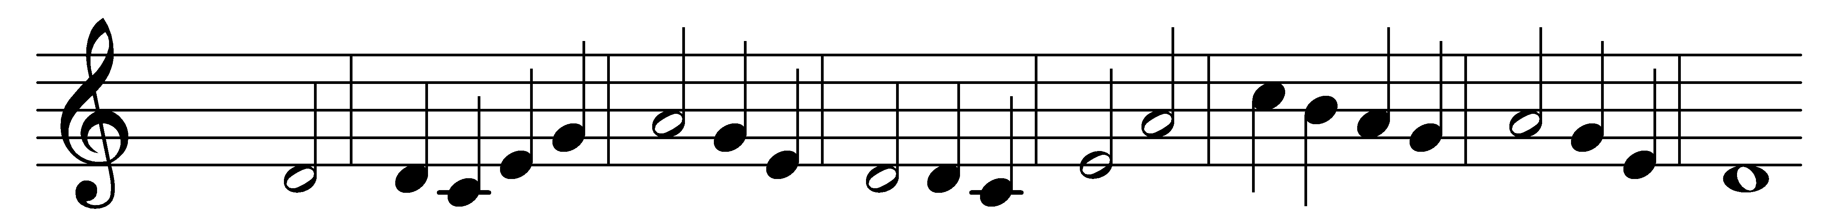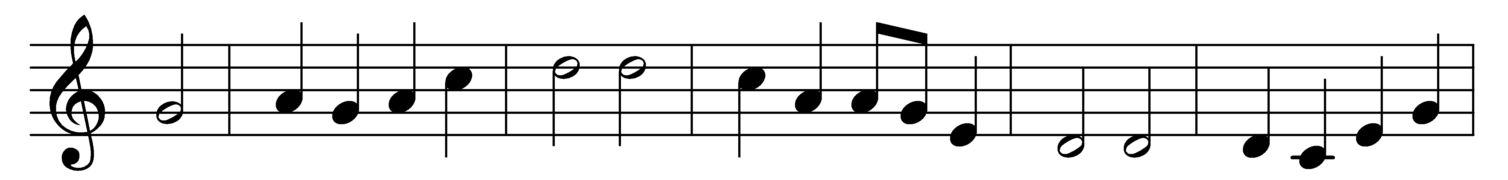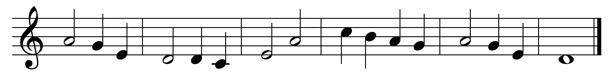

What wondrous love is this, O my soul, O my soul!
What wondrous love is this, O my soul!
What wondrous love is this that caused the Lord of bliss
to lay aside his crown for my soul, for my soul,
to lay aside his crown for my soul.

To God and to the Lamb, I will sing, I will sing,
to God and to the Lamb, I will sing.
To God and to the Lamb, who is the great I AM,
while millions join the theme, I will sing, I will sing,
while millions join the theme I will sing.

And when from death I’m free, I’ll sing on, I’ll sing on,
and when from death I’m free, I’ll sing on.
And when from death I’m free I’ll sing and joyful be,
and through eternity I’ll sing on, I’ll sing on,
and through eternity I’ll sing on.

Words: American folk hymn, c. 1835
Music: From The Southern Harmony, 1835

