For the beauty of the earth Hymnal 1982 no. 416 Melody: Lucerna Laudoniae 7 7. 7 7. 7 7.
Words from AMNS
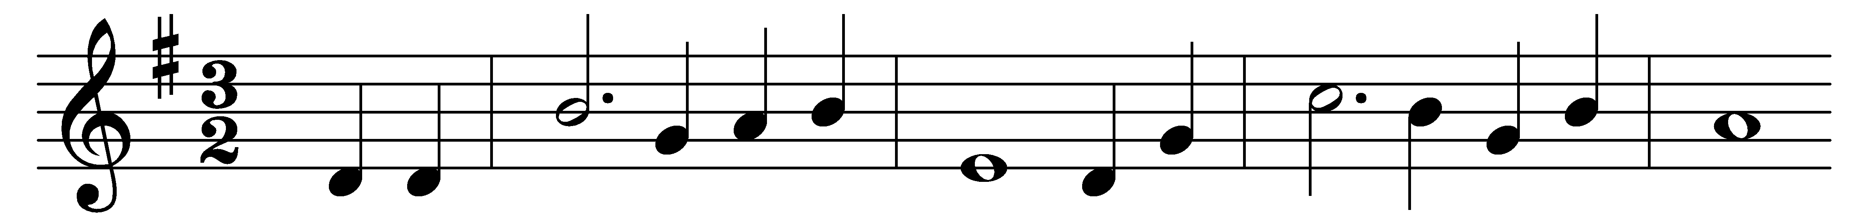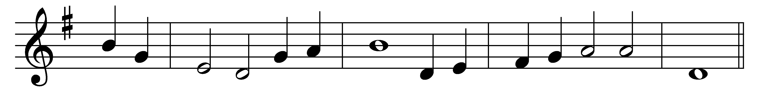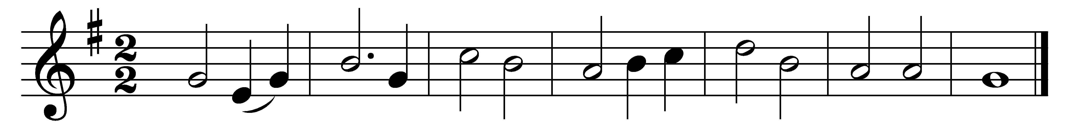

For the beauty of the earth,
for the beauty of the skies,
for the love which from our birth
over and around us lies,
Lord of all, to thee we raise
this our sacrifice of praise.
For the beauty of each hour
of the day and of the night,
hill and vale and tree and flower,
sun and moon and stars of light:
For the joy of human love,
brother, sister, parent, child,
friends on earth, and friends above,
pleasures pure and undefiled:
For each perfect gift of thine,
to our race so freely given,
graces human and divine,
flowers of earth and buds of heaven:

For thy Church which evermore
lifteth holy hands above,
offering up on every shore
her pure sacrifice of love,

Words: Foliott Sandford Pierpoint (1835-1917)
Music: David Evans (1874-1948)

