For the beauty of the earth Hymnal 1982 no. 416 Melody: Lucerna Laudoniae 7 7. 7 7. 7 7.
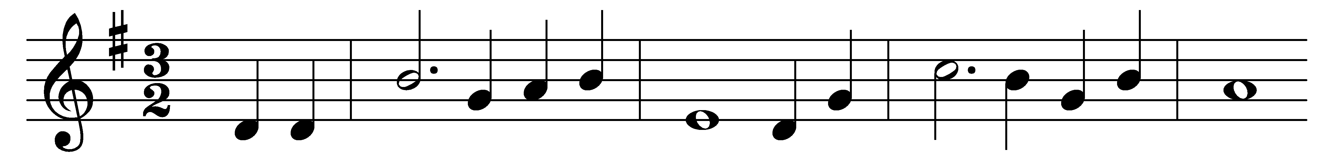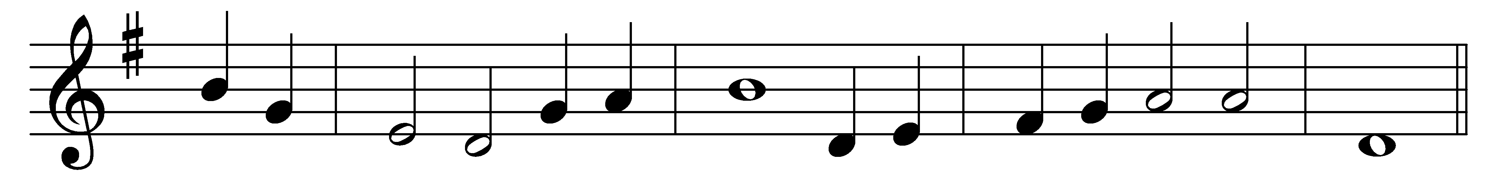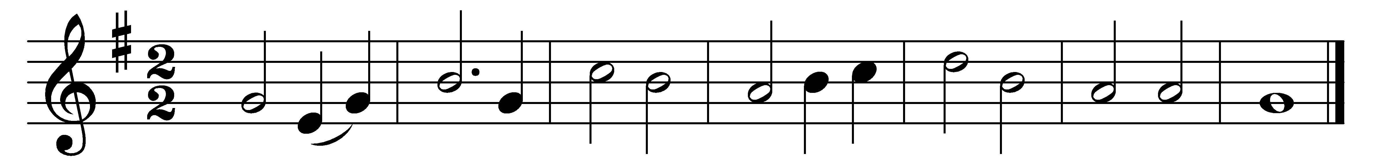

For the beauty of the earth,
for the beauty of the skies,
for the love which from our birth
over and around us lies,
(Refrain:) Christ our God, to thee we raise
this our hymn of grateful praise.

For the beauty of each hour
of the day and of the night,
hill and vale, and tree and flower,
sun and moon, and stars of light, (Refrain)

For the joy of ear and eye,
for the heart and mind’s delight,
for the mystic harmony
linking sense to sound and sight, (Refrain)

For the joy of human love,
brother, sister, parent, child,
friends on earth, and friends above,
for all gentle thoughts and mild, (Refrain)

For the Church which evermore
lifteth holy hands above,
offering up on every shore
thy pure sacrifice of love, (Refrain)

For each perfect gift of thine
to the world so freely given,
faith and hope and love divine,
peace on earth and joy in heaven. (Refrain)

Words: Foliott Sandford Pierpoint (1835-1917)
Music: David Evans (1874-1948)

