When all thy mercies, O my God Hymnal 1982 no. 415 Melody: Durham C.M.

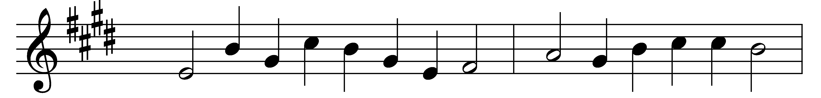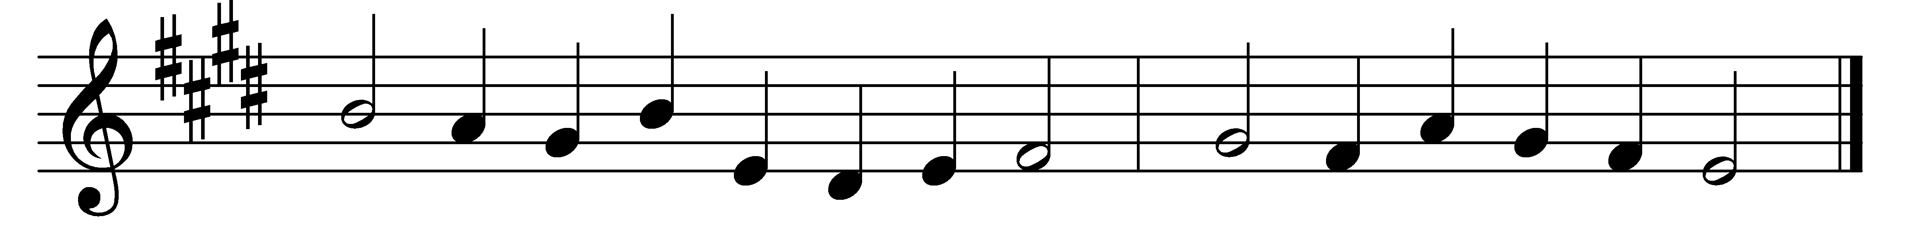

When all thy mercies, O my God,
my rising soul surveys,
transported with the view, I’m lost
in wonder, love, and praise.

O how shall words with equal warmth
the gratitude declare,
that glows within my fervent heart?
But thou canst read it there.

Ten thousand thousand precious gifts
my daily thanks employ;
nor is the least a cheerful heart
that tastes those gifts with joy.

When nature fails, and day and night
divide thy works no more,
my ever grateful heart, O Lord,
thy mercy shall adore.

Through all eternity, to thee
a joyful song I’ll raise;
but oh, eternity’s too short
to utter all thy praise!

Words: Joseph Addison (1672-1719)
Music: Melody and bass by Thomas Ravenscroft (1592?-1635?)

