God, my King, thy might confessing Hymnal 1982 no. 414 Melody: Stuttgart 8 7. 8 7.

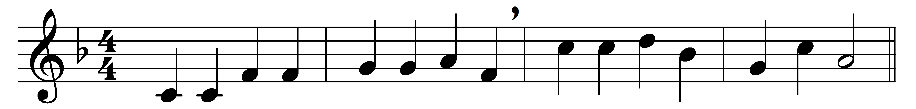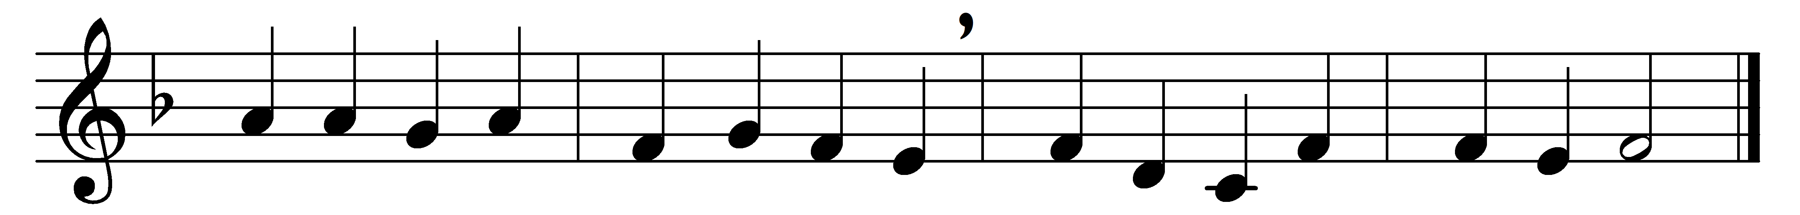

God, my King, thy might confessing,
ever will I bless thy Name;
day by day thy throne addressing,
still will I thy praise proclaim.

Honor great our God befitteth;
who his majesty can reach?
Age to age his works transmitteth,
age to age his power shall teach.

They shall talk of all thy glory,
on thy might and greatness dwell,
speak of thy dread acts the story,
and thy deeds of wonder tell.

Nor shall fail from mem’ry’s treasure
works by love and mercy wrought,
works of love surpassing measure,
works of mercy passing thought.

Full of kindness and compassion,
slow to anger, vast in love,
God is good to all creation;
all his works his goodness prove.

All thy works, O Lord, shall bless thee;
thee shall all thy saints adore:
King supreme shall they confess thee,
and proclaim thy sovereign power.

Words: Richard Mant (1776-1848)
Music: Adapted from a melody by Christian Friedrich Witt (1660-1716)

