The spacious firmament on high Hymnal 1982 no. 409 Melody: Creation D.L.M.
Punctuation from AMNS
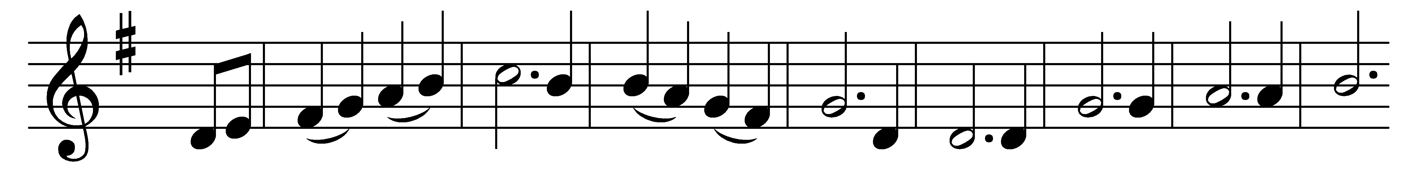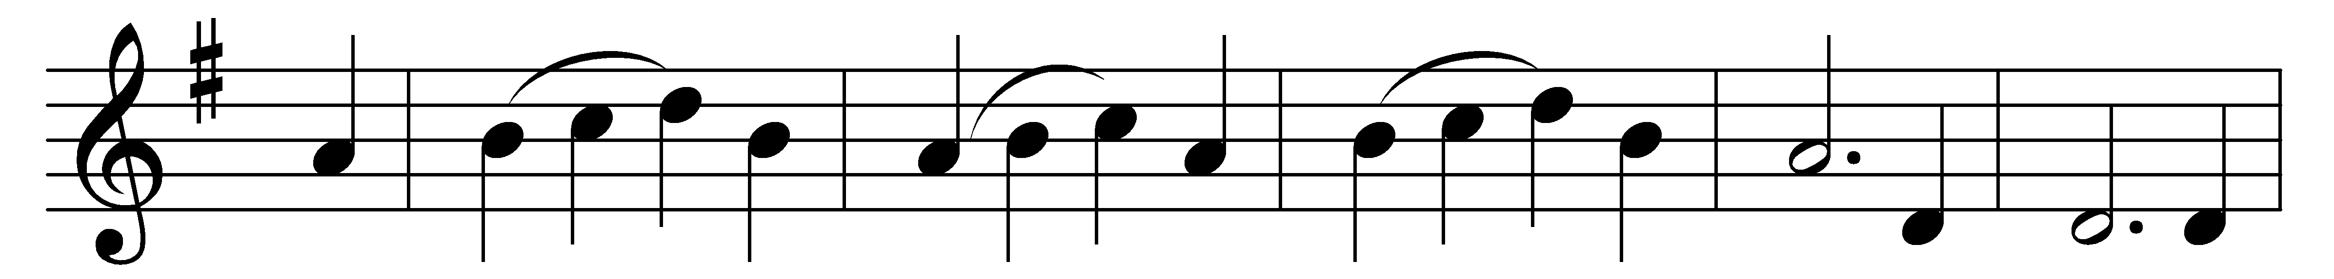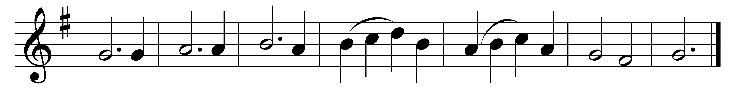

The spacious firmament on high,
with all the blue ethereal sky,
and spangled heavens, a shining frame,
their great Original proclaim.
Th’ unwearied sun from day to day
does his Creator’s power display,
and publishes to every land
the work of an almighty hand.

Soon as the evening shades prevail
the moon takes up the wondrous tale,
and nightly to the listening earth
repeats the story of her birth;
whilst all the stars that round her burn,
and all the planets in their turn,
confirm the tidings, as they roll,
and spread the truth from pole to pole.

What though in solemn silence all
move round the dark terrestrial ball;
what though no reàl voice nor sound
amid their radiant orbs be found;
in reason’s ear they all rejoice,
and utter forth a glorious voice,
for ever singing as they shine,
‘The hand that made us is divine.’

Words: Joseph Addison (1672-1719)
Music: Franz Joseph Haydn (1732-1809), adapted in Dulcimer, or New York Collection of Sacred Music, 1850

