Before the Lord’s eternal throne Hymnal 1982 no. 391 Melody: Winchester New L.M.
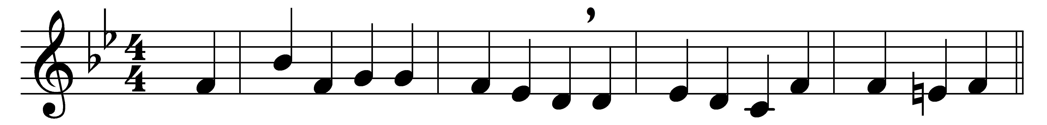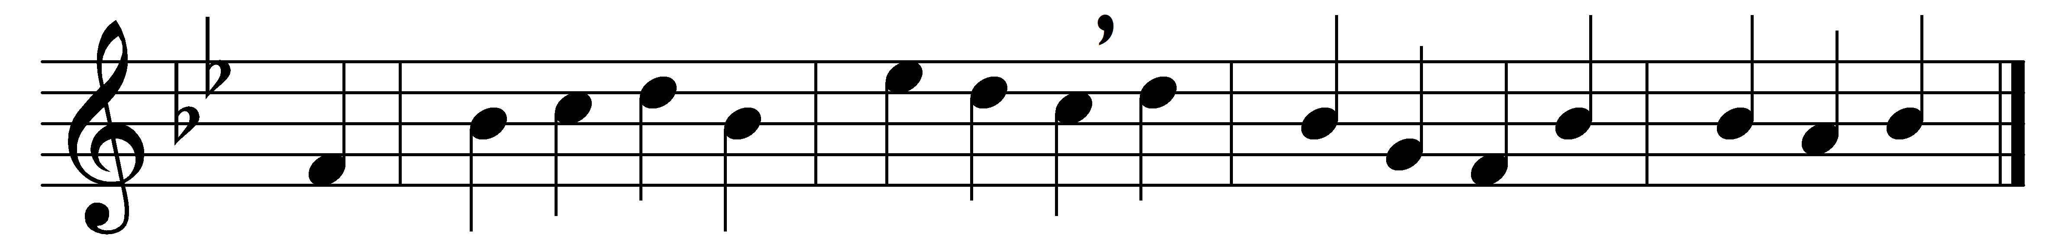

Before the Lord’s eternal throne,
ye nations, bow with sacred joy;
know that the Lord is God alone;
he can create, and he destroy.

His sovereign power without our aid
formed us of clay and gave us breath;
and when like wandering sheep we strayed,
he saved us from the power of death.

We are his people, we his care,
our souls, and all our mortal frame:
what lasting honors shall we rear,
almighty Maker, to thy Name?

We’ll crowd thy gates with thankful songs,
high as the heaven our voices raise;
and earth, with her ten thousand tongues,
shall fill thy courts with sounding praise.

Wide as the world is thy command,
vast as eternity thy love;
firm as a rock thy truth must stand,
when rolling years shall cease to move.

Words: Isaac Watts (1674-1748)
Music: Adapted from Musicalisches Hand-Buch (Hamburg, 1690), harmony by William Henry Monk (1823-1889)

