We sing of God, the mighty source Hymnal 1982 no. 387 Melody: Magdalen College 8 8 6. D.
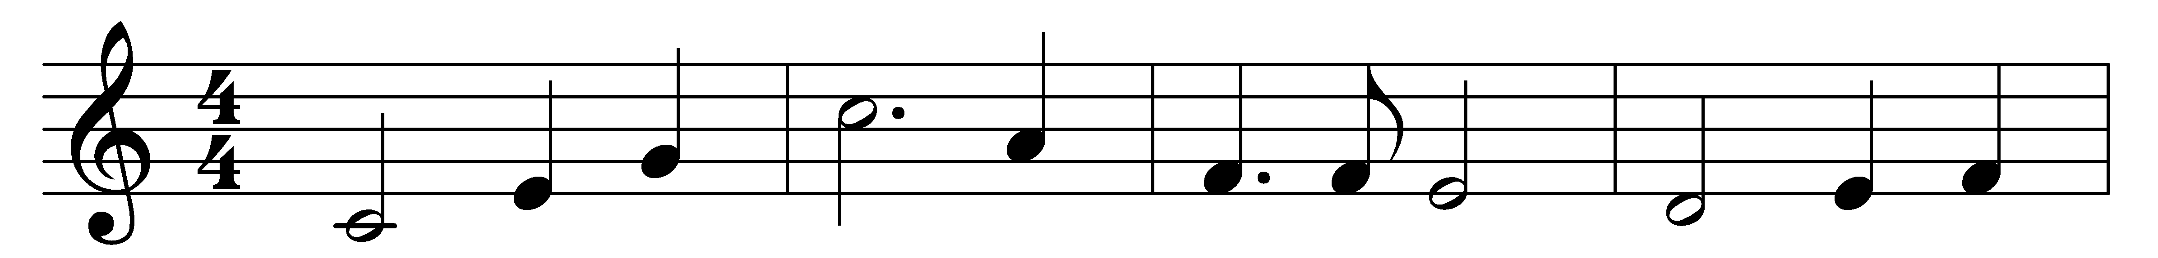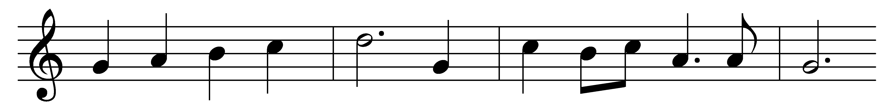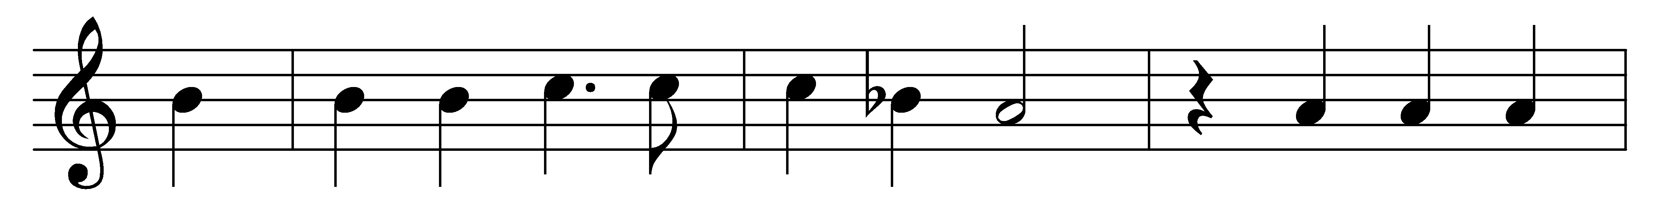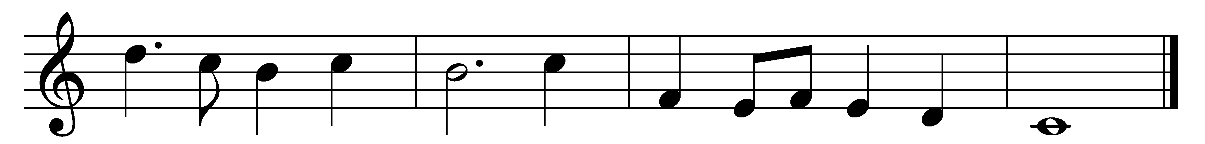

We sing of God, the mighty source
of all things; the stupendous force
on which all strength depends;
from whose right arm, beneath whose eyes,
all period, power, and enterprise
commences, reigns, and ends.

Tell them I AM, the Lord God said,
to Moses while on earth in dread
and smitten to the heart,
at once, above, beneath, around,
all nature without voice or sound
replied, O Lord, thou art.

Glorious the sun in mid career;
glorious th’ assembled fires appear;
glorious the comet’s train:
glorious the trumpet and alarm;
glorious th’ almighty stretched-out arm;
glorious th’ enraptured main:

Glorious, most glorious, is the crown
of him that brought salvation down
by meekness, Mary’s son;
seers that stupendous truth believed,
and now the matchless deed’s achieved,
determined, dared, and done.

Words: Christopher Smart (1722-1771)
Music: William Hayes (1706-1777)

