Fairest Lord Jesus, Ruler of all nature Hymnal 1982 no. 383 Melody: St Elizabeth 5 6 8. 5 5 8.
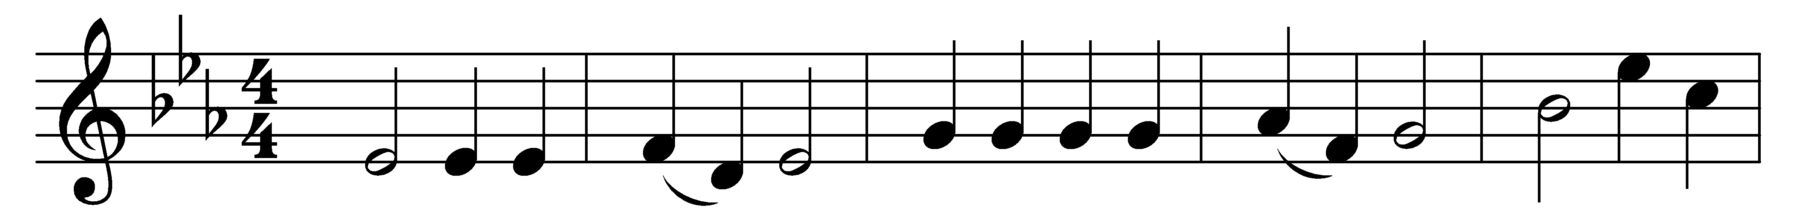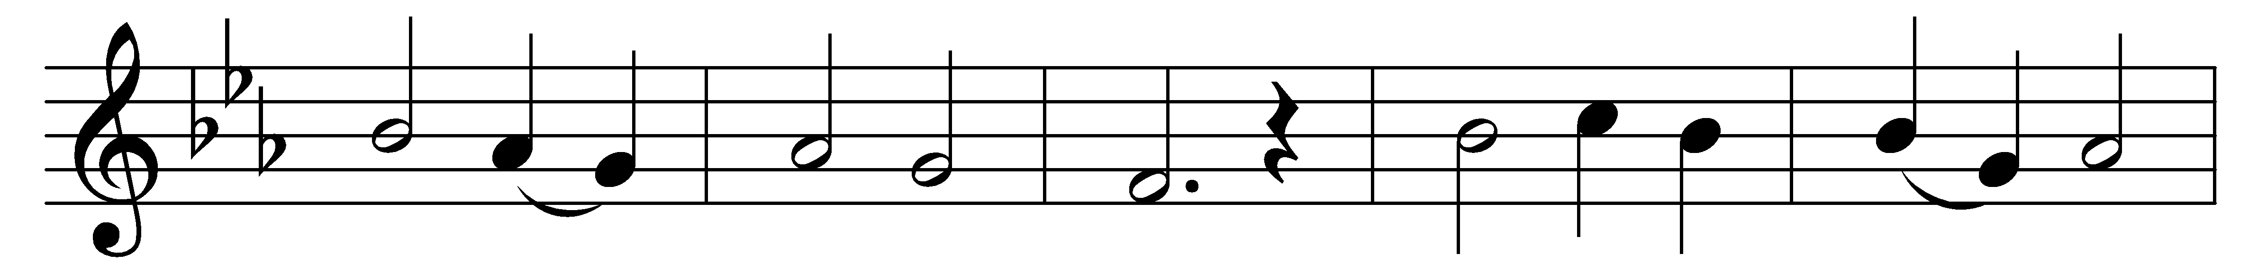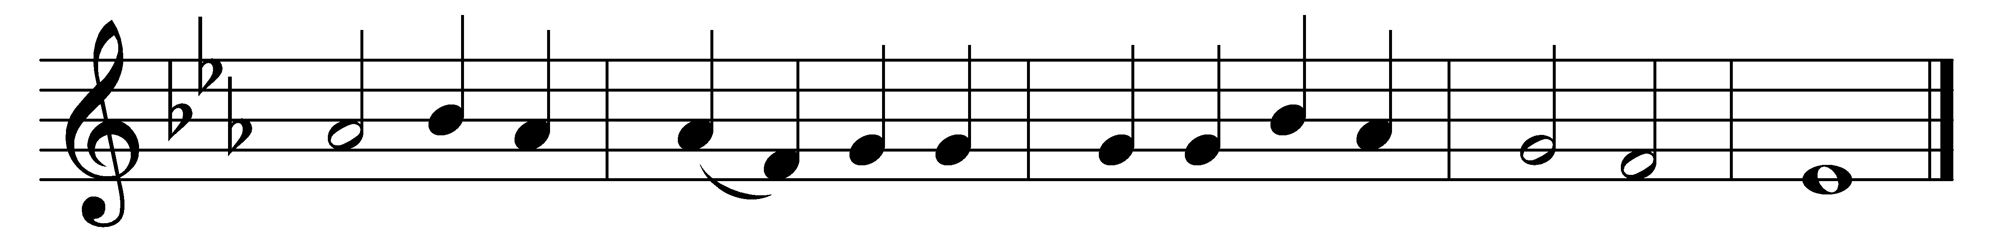

Fairest Lord Jesus, Ruler of all nature,
O thou of God and man the Son;
thee will I cherish, thee will I honor,
thou, my soul’s glory, joy, and crown.

Fair are the meadows, fairer still the woodlands,
robed in the blooming garb of spring:
Jesus is fairer, Jesus is purer,
who makes the woeful heart to sing.

Fair is the sunshine, fairer still the moonlight,
and all the twinkling, starry host:
Jesus shines brighter, Jesus shines purer,
than all the angels heaven can boast.

Words: German composite, translation published in New York, 1850
Music: Melody from Schlesische Volkslieder, 1842

