From all that dwell below the skies Hymnal 1982 no. 380 Melody: Old 100th L.M.
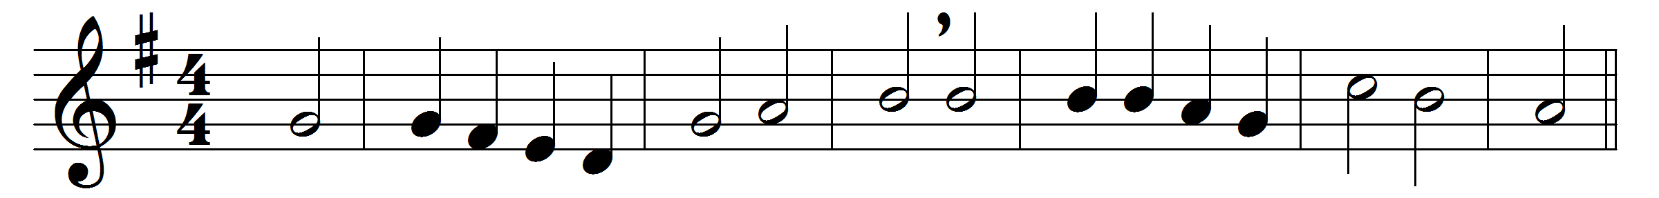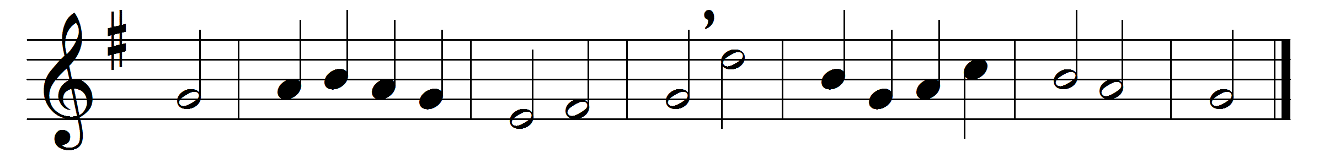

From all that dwell below the skies
let the Creator’s praise arise!
Let the Redeemer’s Name be sung
through every land, by every tongue!

Eternal are thy mercies, Lord,
and truth eternal is thy word:
thy praise shall sound from shore to shore
till suns shall rise and set no more.

Praise God, from whom all blessings flow;
praise him, all creatures here below;
praise him above, ye heavenly host:
praise Father, Son, and Holy Ghost.

Words: Isaac Watts (1674-1748) and Thomas Ken (1637-1711)
Music: Melody in Genevan Psalter, 1551

