I bind unto myself today Hymnal 1982 no. 370 Melodies: St Patrick’s Breastplate, Deirdre D.L.M.
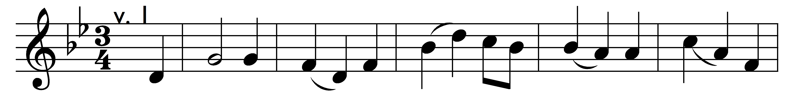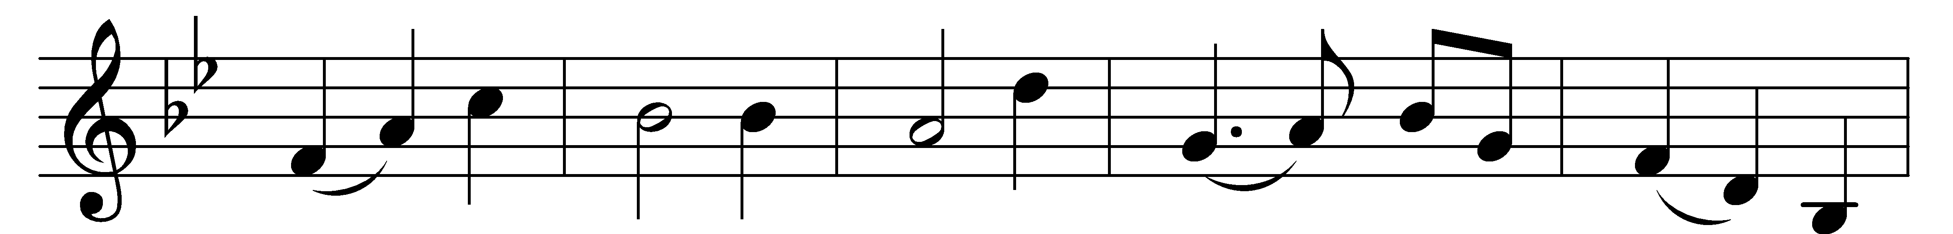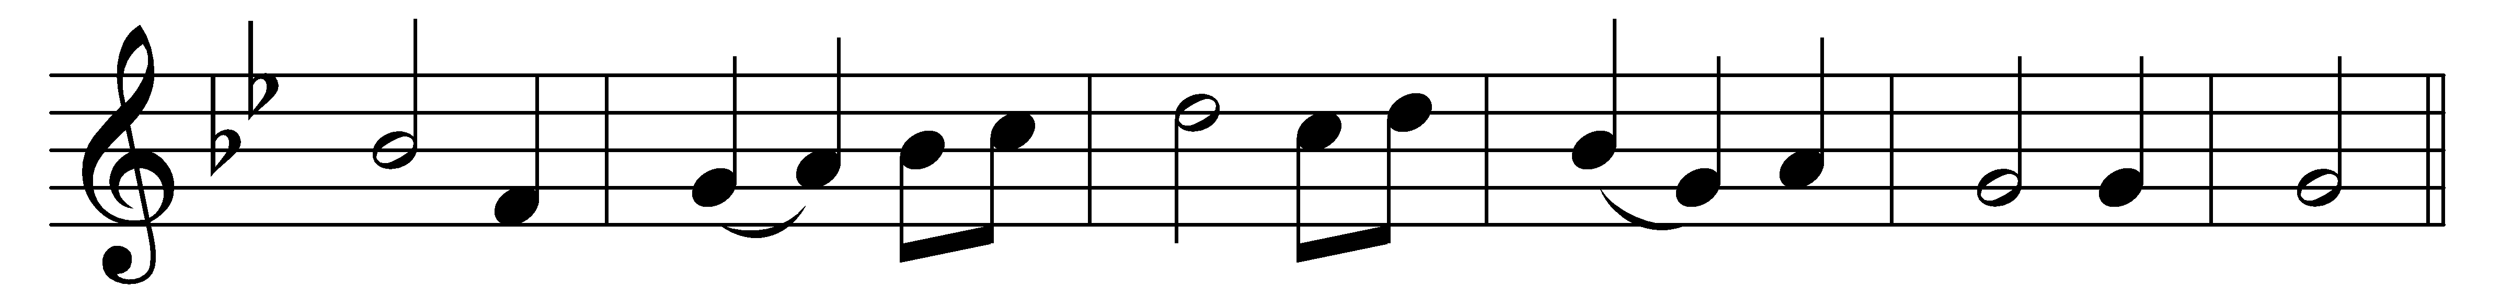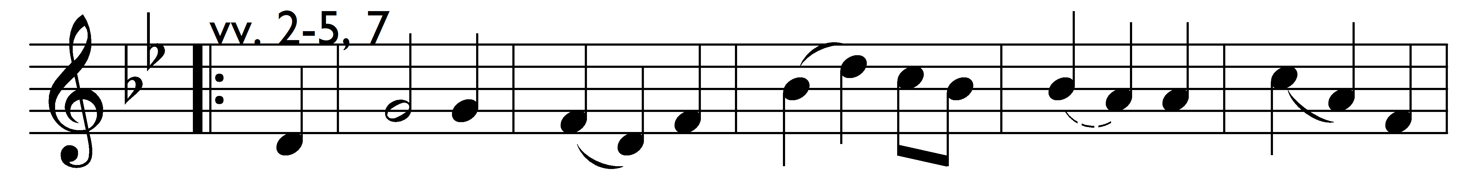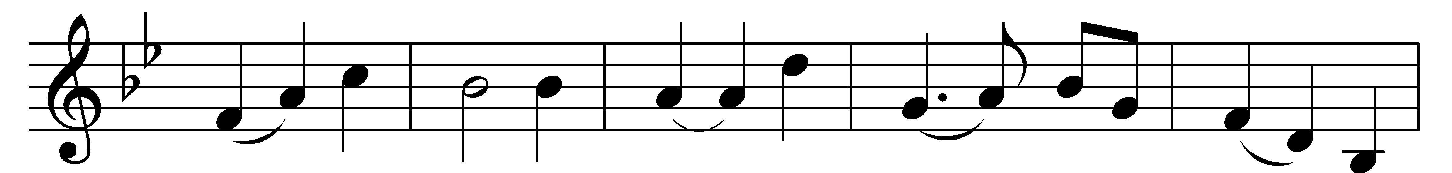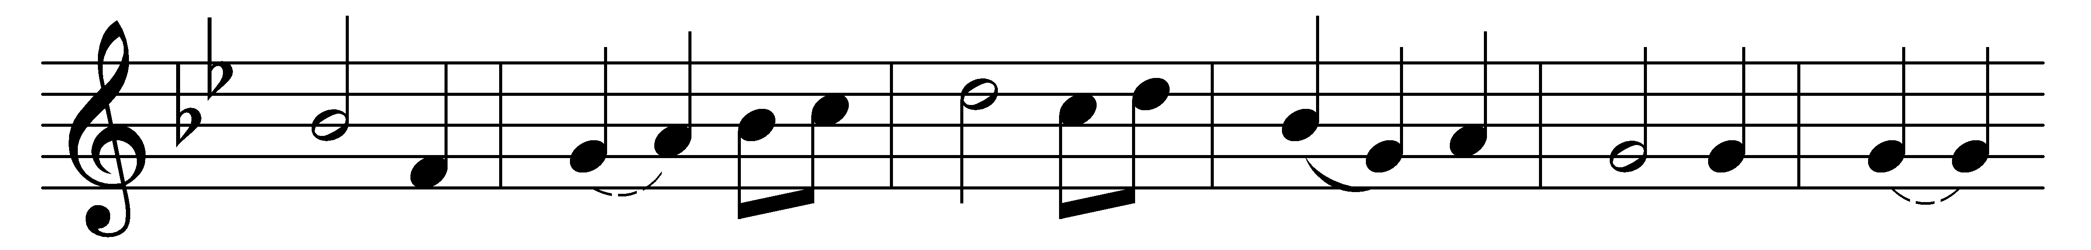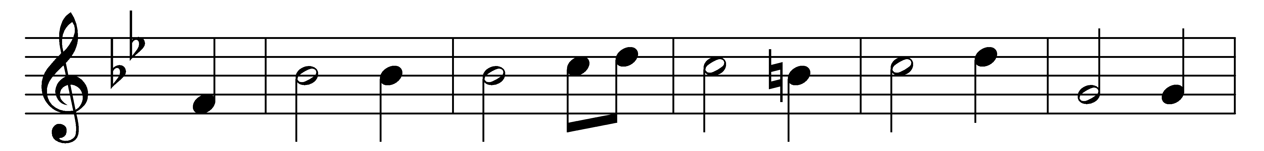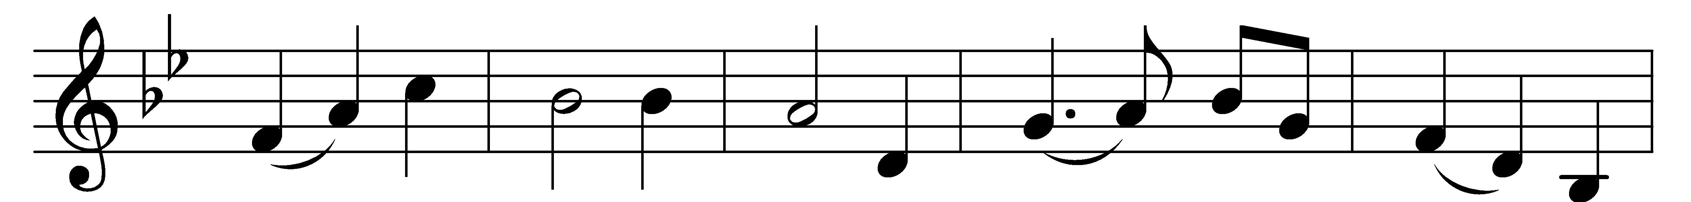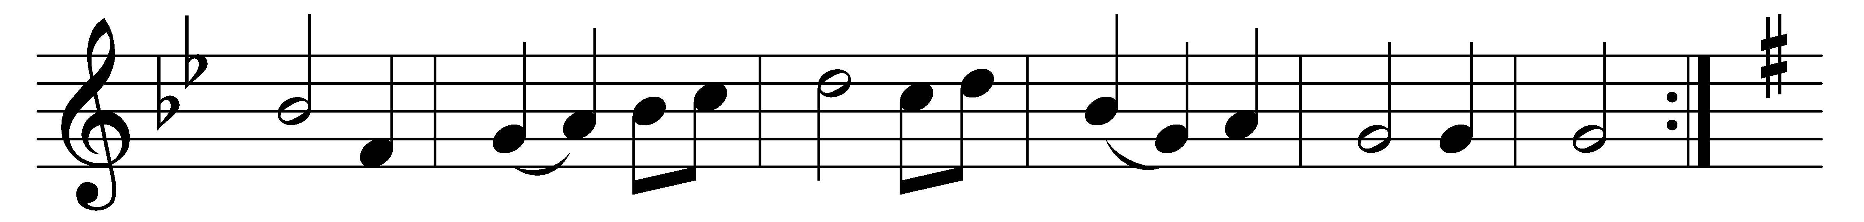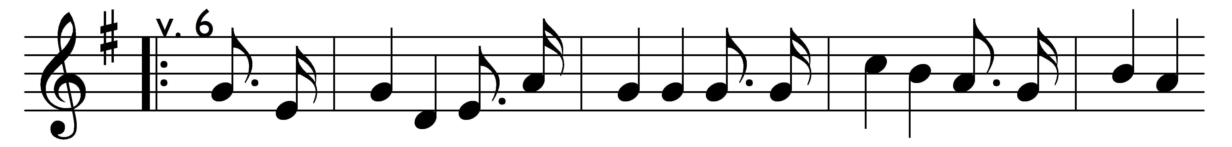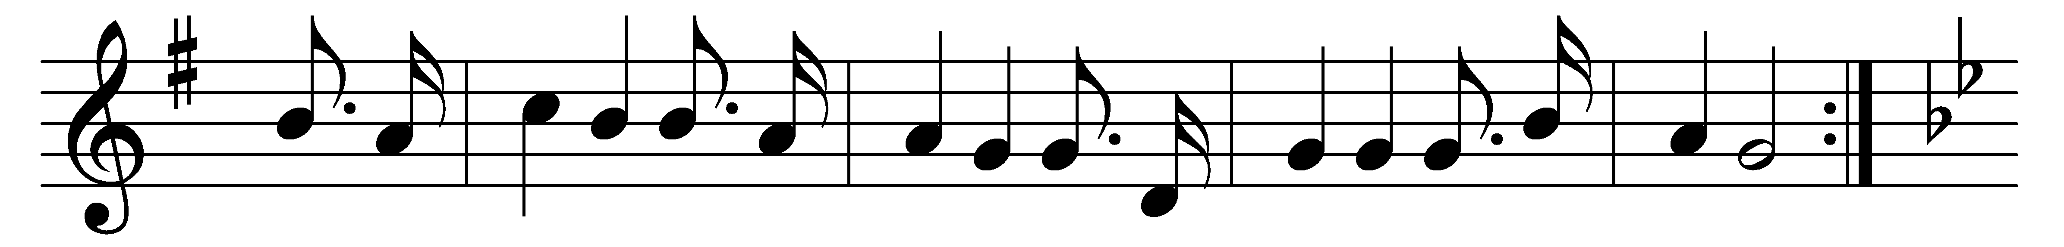

I bind unto myself today
the strong Name of the Trinity,
by invocation of the same,
the Three in One, and One in Three.

I bind this day to me for ever,
by power of faith, Christ’s Incarnation;
his baptism in the Jordan river;
his death on cross for my salvation;
his bursting from the spicèd tomb;
his riding up the heavenly way;
his coming at the day of doom:
I bind unto myself today.

I bind unto myself the power
of the great love of cherubim;
the sweet “Well done” in judgment hour;
the service of the seraphim;
confessors’ faith, apostles’ word,
the patriarchs’ prayers, the prophets’ scrolls;
all good deeds done unto the Lord,
and purity of virgin souls.

I bind unto myself today
the virtues of the star-lit heav’n,
the glorious sun’s life-giving ray,
the whiteness of the moon at ev’n,
the flashing of the lightning free,
the whirling wind’s tempestuous shocks,
the stable earth, the deep salt sea,
around the old eternal rocks.

I bind unto myself today
the power of God to hold and lead,
his eye to watch, his might to stay,
his ear to hearken, to my need;
the wisdom of my God to teach,
his hand to guide, his shield to ward;
the word of God to give me speech,
his heavenly host to be my guard.

Christ be with me, Christ within me,
Christ behind me, Christ before me,
Christ beside me, Christ to win me,
Christ to comfort and restore me,
Christ beneath me, Christ above me,
Christ in quiet, Christ in danger,
Christ in hearts of all that love me,
Christ in mouth of friend and stranger.

I bind unto myself the Name,
the strong Name of the Trinity,
by invocation of the same,
the Three in One, and One in Three.
Of whom all nature hath creation,
eternal Father, Spirit, Word:
praise to the Lord of my salvation,
salvation is of Christ the Lord.

Words: Attributed to Patrick (372-466), translated by Cecil Frances Alexander (1818-1895)
Music: Irish melodies, St Patrick’s Breastplate adapted by Charles Villiers Stanford (1852-1924)

