Bright the vision that delighted Hymnal 1982 no. 367 Melody: Rustington 8 7. 8 7. D.
Words from AMNS
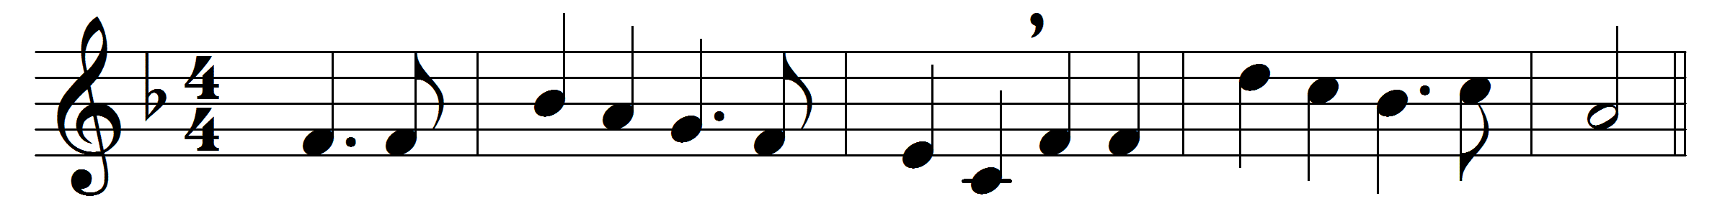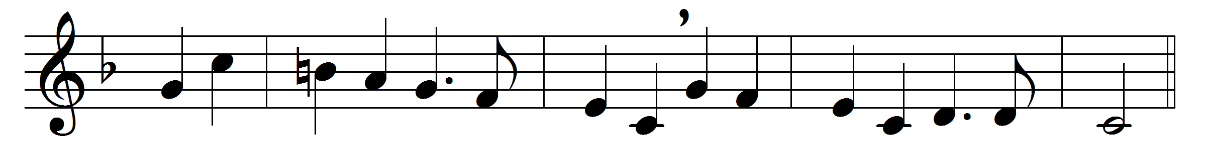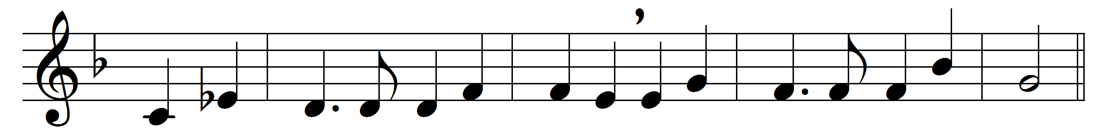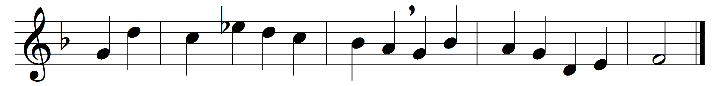

Bright the vision that delighted
once the sight of Judah’s seer;
sweet the countless tongues united
to entrance the prophet’s ear.

Round the Lord in glory seated
cherubim and seraphim
filled his temple, and repeated
each to each the alternate hymn:

‘Lord, thy glory fills the heaven;
earth is with its fulness stored;
unto thee be glory given,
holy, holy, holy, Lord.’

Heaven is still with glory ringing,
earth takes up the angels’ cry,
‘Holy, holy, holy,’ singing,
‘Lord of hosts, the Lord most high.’

With his seraph train before him,
with his holy Church below,
thus unite we to adore him,
bid we thus our anthem flow:

‘Lord, thy glory fills the heaven;
earth is with its fulness stored;
unto thee be glory given,
holy, holy, holy, Lord.’

Words: Richard Mant (1776-1848)
Music: Charles Hubert Hastings Parry (1848-1918)

