Round the Lord in glory seated Hymnal 1982 no. 367 Melody: Rustington 8 7. 8 7. D.
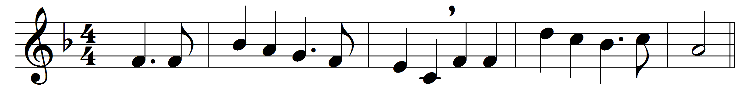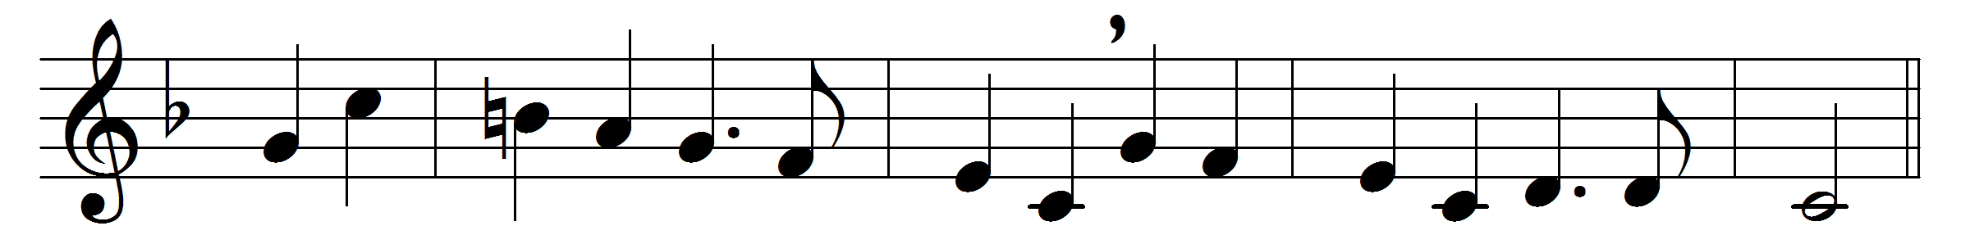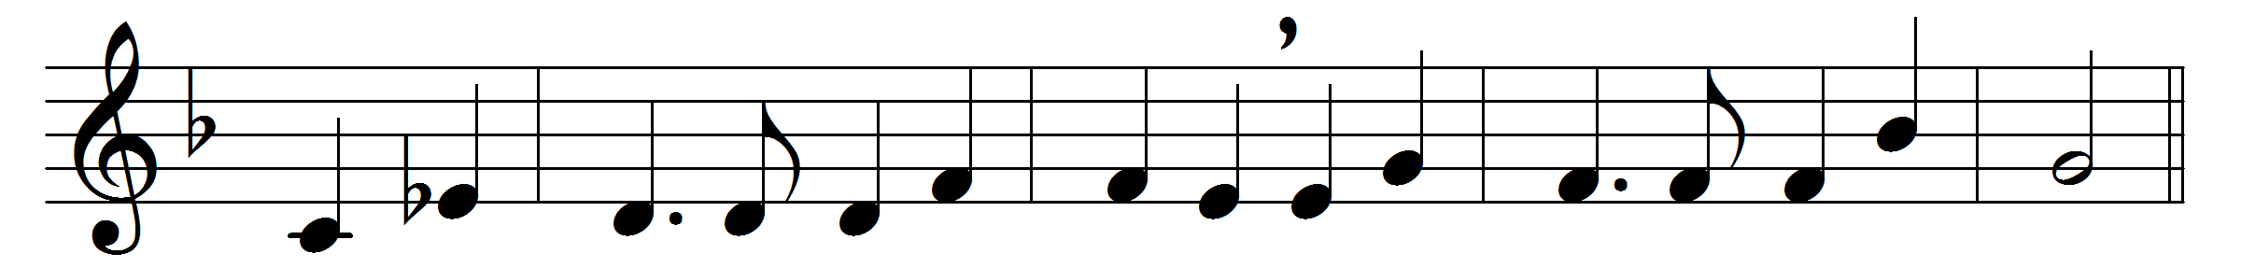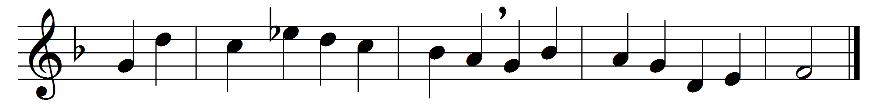

Round the Lord in glory seated
cherubim and seraphim
filled his temple, and repeated
each to each th’alternate hymn:
‘Lord, thy glory fills the heaven,
earth is with thy fullness stored;
unto thee be glory given,
holy, holy, holy Lord!’

Heaven is still with glory ringing,
earth takes up the angels’ cry,
‘Holy, holy, holy,’ singing,
‘Lord of hosts, the Lord Most High.’
With his seraph train before him,
With his holy Church below,
thus unite we to adore him,
bid we thus our anthem flow:

‘Lord, thy glory fills the heaven,
earth is with thy fullness stored;
unto thee be glory given,
holy, holy, holy Lord!’
Thus thy glorious Name confessing,
with thine angel hosts we cry
‘Holy, holy, holy,’ blessing
thee, the Lord of hosts Most High.

Words: Richard Mant (1776-1848)
Music: Charles Hubert Hastings Parry (1848-1918)

