Come, thou almighty King Hymnal 1982 no. 365 Melody: Moscow 6 6 4. 6 6 6 4.
British spelling
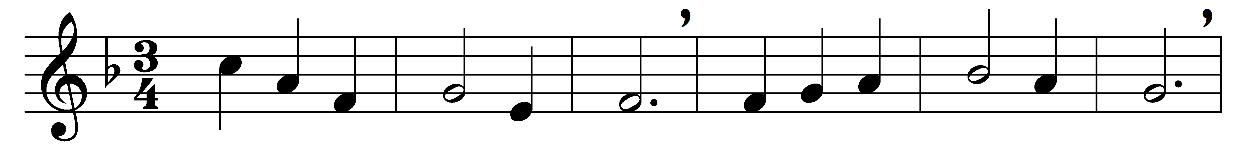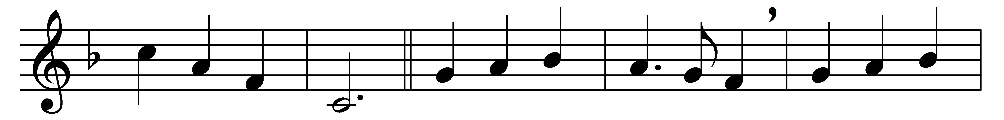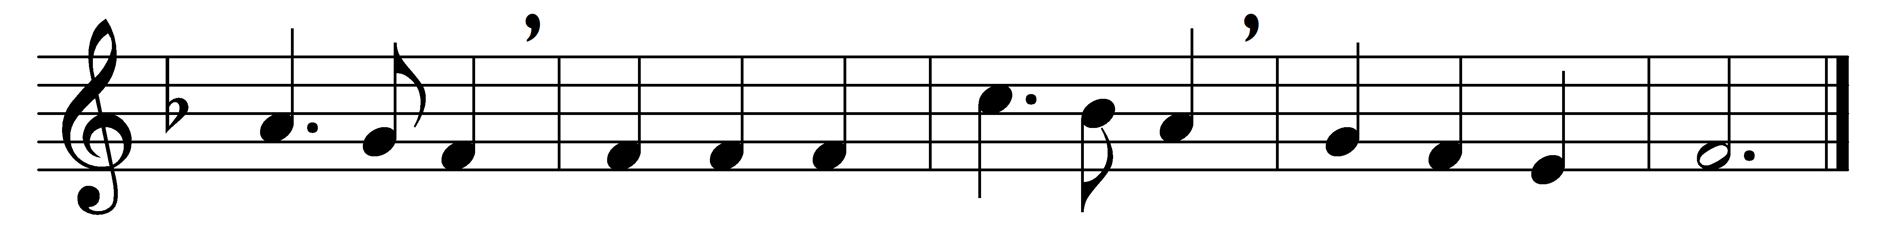

Come, thou almighty King,
help us thy Name to sing,
help us to praise.
Father whose love unknown
all things created own,
build in our hearts thy throne,
Ancient of Days.

Come, thou incarnate Word,
by heaven and earth adored;
our prayer attend:
come, and thy people bless;
come, give thy word success;
stablish thy righteousness,
Saviour and friend.

Come, holy Comforter,
thy sacred witness bear
in this glad hour:
thou, who almighty art,
now rule in every heart,
and ne’er from us depart,
Spirit of power.

To Thee, great One in Three,
the highest praises be,
hence evermore;
thy sovereign majesty
may we in glory see,
and to eternity
love and adore.

Words: Anonymous, c. 1757
Music: Felice de Giardini (1716-1796), harmony from The New Hymnal, 1916

