Jesus, Son of Mary, fount of life alone Hymnal 1982 no. 357
Melody: Adoro te devote 11 11. 11 11.
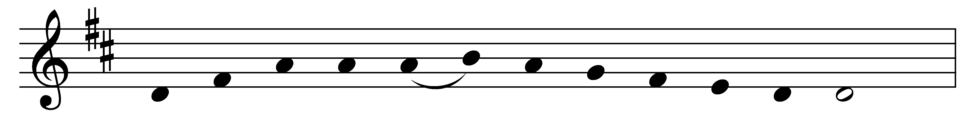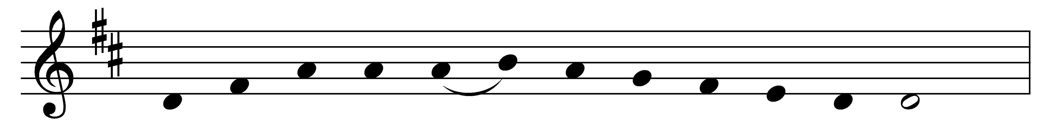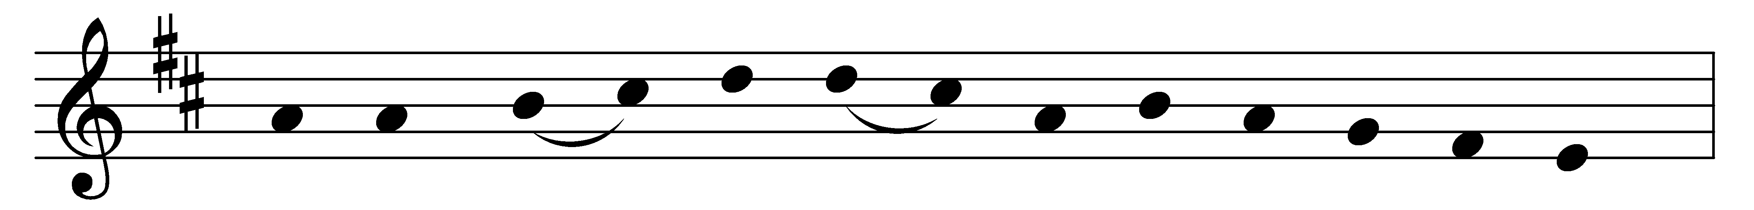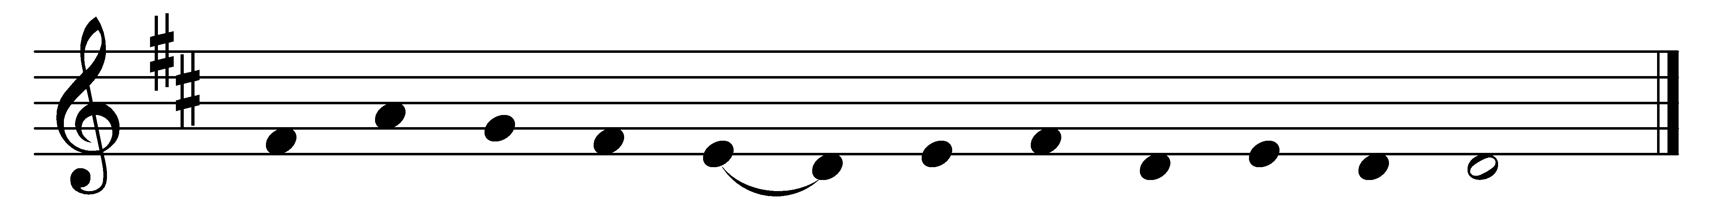

Jesus, Son of Mary, fount of life alone,
now we hail thee present on thine altar throne.
Humbly we adore thee, Lord of endless might,
in the mystic symbols veiled from earthly sight.

Think, O Lord, in mercy on the souls of those
who, in faith gone from us, now in death repose.
Here mid stress and conflict toils can never cease;
there, the warfare ended, bid them rest in peace.

Often were they wounded in the deadly strife;
heal them, Good Physician, with the balm of life.
Every taint of evil, frailty and decay,
good and gracious Savior, cleanse and purge away.

Rest eternal grant them, after weary fight;
shed on them the radiance of thy heavenly light.
Lead them onward, upward, to the holy place,
where thy saints made perfect gaze upon thy face.

Words: Edmund Stuart Palmer (1856-1931)
Music: Mode v, French church melody, Processionale, 1697

