Wherefore, O Father, we thy humble servants Hymnal 1982 no. 338
Melody: Lobet den Herren 11 11. 11. 5.
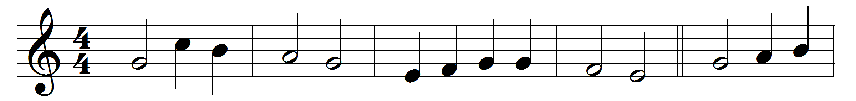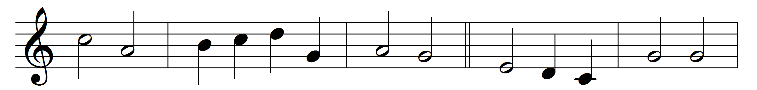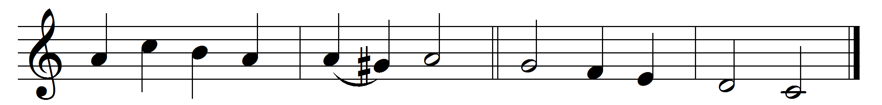

Wherefore, O Father, we thy humble servants
here bring before thee Christ thy well-belovèd,
All-perfect Offering, sacrifice immortal,
spotless oblation.

See now thy children, making intercession
through him our Savior, Son of God incarnate,
for all thy people, living and departed,
pleading before thee.

Words: William Henry Hammond Jervois (1852-1905)
Music: Melody by Johann Crüger (1598-1662), harmony by Friedrich Layriz (1808-1859)

